

Evaluation Report:

Focus on Families
(A family-focused mental health project for residents of Knowle West)

Knowle West
Health Park Company

Written by Mandy Shute
Contents Page Page Number

- Summary 3

- Evaluation Process 3

- Project Overview 5

4. Findings
4a Responses from Clients 7
4b Responses from Partners and Stakeholders 10

- Statistics 13

- Case Studies 18

- Cost Analysis 20

- Conclusion 23

- Recommendations 24

- Appendix 1: Partner Details 25

- Appendix 2: Client Quotes 26

- Appendix 3: Monitoring tools 28

Focus on Families.
Managed by Knowle West Health Park Company and funded by the Big Lottery, Reaching Communities Programme

- Summary
Focus on Families is a Big Lottery (Reaching Communities) funded programme that started in February 2010, managed by Knowle West Health Park Company. Its aim was to work with Partners, Stakeholders and Residents of Knowle West to deliver a range of services and to address mild to moderate mental health needs. These services included one to one services, group work, workshops and longer term programmes.

The needs identified in the area were:
Counselling for men
Counselling for women
Family and children counselling
Parenting programmes
Family Conferencing
Parenting Network
1:1 Psychodrama Psychotherapy
Group Psychodrama Psychotherapy
Psycho-educational sessions
Play Therapy

The purpose of this evaluation was to assess the Focus on Families (FoF) project from the client’s point of view, through consultation with the partners and stakeholders that worked with Knowle West Health Park Company (KWHPC).

- Evaluation Process
Partners, stakeholders and clients who participated in the project were contacted by an evaluator and asked a pre-determined set of questions. The questions were agreed and set by KWHPC. The majority of the contacts were made by telephone. All clients remained anonymous. Clients were not asked about their ethnicity nor were they specifically asked to give their age, although it can be deduced that this sample includes a range of ages from younger (teenagers) to older people (65+), based upon the activities they attended.

A total of 69 clients were contacted.

Each client was asked the same questions.
1. How long did they stay?
2. How were they referred?
3. Was there a wait?
4. Why did they access the programme?
5. What differences did the project make to them?
6. Would they recommend it to others?
7. What was their first impression?
8. Did this change at all?
9. What were the staff like?
10. Was there anything they did not like?
11. What would they like to see improved?
12. Were they offered any additional support?
13. What were they doing now?
14. Was there anything else they would like to add?

Each partner or stakeholder was asked the same questions, as follows:

1. What part of FoF did you provide?
2. How did you initially get involved?
3. What were communications with KWHPC like?
4. Was there sufficient support from KWHPC?
5. Would you work with KWHPC again?
6. What would you improve?
7. What went well?
8. Would you recommend KWHPC as a partner to other organizations?
9. Were the reporting systems accessible and easy to use?
10. How many clients were referred to your service?
11. Did you refer clients to other parts of the service?
12. Would you support the project if additional funding were secured?
13. Given funding restraints do you feel that the service you offered adequately met local need?
14. What else could you have provided if further resources were available to meet local need?

Duration of assessment
It was initially assessed that the evaluation would take roughly one month, but it actually turned into a 2 month process.

Experiences contacting clients
It was difficult trying to get clients to respond on the phone, at least initially, because many didn’t recognize the name Focus on Families (FoF). However, starting with “I think you may have just done a course on…” elicited a more positive response. Clients then explained what course they had been on and I would confirm that it was a FoF project.

Each phone call on average took about half an hour to an hour but this was because it took a while to establish what FoF was, even though all clients had completed an agreement for the evaluator to phone them.

On the whole, clients were more than happy to discuss their experiences on the FoF project. Some, in fact, wanted to tell the evaluator their whole life story!

Personal Reflections
It has been a very positive experience evaluating this project. I have enjoyed listening to clients stories and hearing about the improvements they have made as a result of attending this project.

Overall this is a very positive evaluation with the courses and sessions offered being highly thought of both by partners and clients. It may seem a little too positive in some ways, with very little negative responses coming from the clients in particular. However, this is a true and accurate report of those conversations with the clients, partners and stakeholders.

3. Project Overview

Focus on Families is a three-year project, funded by the BIG Lottery’s Reaching Communities programme. It is hosted by Knowle West Health Park Company (KWHPC), a charity situated upon the Knowle West Health Park.

About Knowle West Health Park Company (KWHPC)
KWHPC was created to tackle health inequality and promote health and well-being for residents living locally and in south Bristol. The Company aims to provide high quality services to prevent illness, promote good health and assist recovery after medical treatment. It has an established history of providing consistent, high quality services in the area. The majority of the Company’s Board of Directors are local people, who share extensive experience of managing local charities and companies, with additional representatives from Bristol City Council, NHS Bristol and other key local partner agencies.

Background
Focus on Families was set up as a response to the high levels of deprivation, including mental health issues and numbers of vulnerable adults and children, living within Filwood Ward, Bristol. Evidence shows that families are often trying to cope in isolation, lacking support from family and friends. Historically, the services which do exist are often inaccessible because they are not local or the provision is for acute problems only.

Statistically, Filwood continues to suffer from the effects of health inequalities (by ward), including:
- It is in the top two wards for numbers of children with mental health disorders
- It is in the top two wards for the % of children in care 2006-2007
- Its young people are in the highest ranked ward for vulnerability to substance misuse
- It had the highest cancer mortality rate for Bristol between 2002-2006
- It had the highest rate of coronary heart disease mortality between 2002-2006
- It is in the top five wards for numbers of people living with limiting long-term conditions
- It is in the top two wards for the numbers of people claiming DLA
(Joint strategic needs assessment October 2008)

Types of Interventions and Service Delivery
Focus on Families works in partnership with established agencies, including Barnardos, Womankind, Butterfly and other experienced, qualified professionals, to deliver the following interventions for free:
- General counselling for individuals and families
- Play Therapy for children/young people
- Psychotherapy groups
- Parenting courses/classes
- Psychological education workshops on stress, anger management and anxiety, amongst others

All of the services are confidential, and are intended for people who are suffering from mild to moderate mental health issues, including the effects of violence, abuse, bereavement, isolation and other traumatic events. Families who are struggling to cope, or who are in conflict, are also being offered support.

There is an emphasis upon working systemically with both individuals and the family context within which those individuals are situated. Furthermore, while all interventions aim to be responsive to local need and are delivered using established methods, attention is given to ongoing service development and innovation, where necessary.

Monitoring and Evaluation
All partners are required to evidence both the attendance and quality of their services, by providing regular reports to comment upon their progress against performance targets and upon their capacity to deliver against the following five outcomes agreed with the Big Lottery:
- Improving mental health and wellbeing
- Improving positive family relationships
- Reducing social isolation
- Improving ability to cope
- Improving behavioural issues

4. Findings

4a Responses from Clients:

- How long did they stay in the project?
Using the figures provided by KWHPC the average stay seems to be 6 months. There were clients who were accessing services provided by KWHP prior to the FoF project starting and they had a seamless transfer to the FoF project.

- How were they referred into the project?
Referrals came from a variety of different sources with self referral high on the list. GPs, health visitors, friends, Fit and Fab and social workers were also mentioned. Of the 69 clients that were spoken to:
- GP's 34%
- Self-referral 27%
- Social workers 29%,
- Other (Fit and Fab, Knowle West Health Association, Police) 10%
(these figures are approximate and the data collected by KWHPC on referrals is provided later on in the report)

3. Was there a wait to start?
There was an average wait of 4 weeks for both the group work and one to one sessions.

4. Why did the person access the programme?
There was a varied response as to why clients accessed Focus on Families, although clients were not always specific about why they had accessed the project. When asked this question, many commented that they needed some help to cope.

The respondents can be grouped into the following general categories:
Parenting Classes (34.2%)
Counselling/Psychosocial groups (62.2%)
Other (includes alcohol support) (0.6%)
Not stated (3%)

- What difference did the project make to them?
Responses from clients could be fitted into 5 broad themes:
- Improvements in mental health and wellbeing: 64%
- Family relationships improved: 38%
- Social Isolation reduced: 78%
- Behavioral problems reduced: 43%
- Ability to cope with day to day decisions improved: 72%

In addition, 1 person specifically mentioned that the project helped him reduce his alcohol intake.

Quotes from clients can be seen in Appendix 2.

6. Would they recommend the programme to other people?
100% of respondents said they would recommend this programme to a friend.

7. What was the person’s first impression of the service?
84% of the people contacted said that they were anxious or concerned about what to expect. The remaining 16% said that they did not know what to expect.

The word “anxious” was used a great deal, linked to thinking they were the only ones with real problems. Many people used the word “scared": “scared” they would make a fool of themselves, “scared” that they would not be able to understand what was going on.

8. Did their first impression change at all?
The people who reported feeling anxious or scared reported that their feelings changed as the work progressed. There was very positive feedback on the changes the project had made to them.

Quotes are in Appendix 2.

9. What were the staff like?
Again, a very positive response to this question. There were no negative comments about any of the service providers.

Quotes are in Appendix 2.

10. Was there anything you didn’t like?
There were no direct negative comments about anything, although some commented that the service “stopped too soon”.

11. What would they like to see improved?
Most said they didn't really want to comment on this question, although the following improvements were suggested:
- Housing support was mentioned 3 times
- It would be nice to have some holistic treatments (it was not assumed that this would be provided by the FoF project)
- "Please don't stop them" (courses)
- "Could we offer it to other members of the family?", suggesting that clients need to know if that is possible

12. Were they offered any additional support?
About 50% of the people questioned were still attending or continuing to receive help in one form or another. Others were offered a range of different support.
- 5 people were still attending counselling courses,
- 4 clients were accessing some additional family support now they understood their own need.
- 5 clients said they were offered continued support on the phone
- Around 30 were still attending courses or one to one support
- Many are now attending other activities each week, on the Health Park. “Fit and Fab” and “Health Matters” were specifically mentioned.
- Almost 30% of clients are still accessing their GPs for support.

13. What were they doing now?
Similar answers to above. Fit and Fab were mentioned, as well as Health Matters, both provided by KWHPC. There were some clients (15%) who felt they would have benefitted from longer term support. One gentleman when asked this question was very proud to say that he was still sober! There were 3 clients who had attended local mental health facilities, or hospitals that were no longer in need of these services at this time.

14. Was there anything else they would like to add?
There were many positive comments to this question. Please refer to quotes in Appendix 2.

4b Responses from Partners and Stakeholders

- What part of FoF did you provide?
I spoke to a good cross section of those delivering the services – including partner agencies and workers/facilitators - as well as those referring into the service.

Workers included those delivering 1:1 counselling and psychotherapy (either contracted independently or working for bigger organizations) as well as groupwork interventions i.e. parenting/family work and psychosocial groups.

- How did you initially get involved?
Most were contacted by the Operations Manager or CEO of KWHPC. Some providers were already delivering services in Knowle West, and were asked to provide additional services.

- What were communications with KWHPC like?
There was a mixed response on this question, ranging from “excellent” to “a bit disorganised to begin with”. Generally speaking, there was very positive feedback on the communications and even those who commented on the disorganisation at the beginning of the programme agreed that it improved greatly over time.

There was a comment asking for more formal introductions to the whole team at the beginning of the project which some felt would have been useful.

- Was there sufficient support from KWHPC?
The response to support at the start of the project from KWHPC was very positive, on the whole. There were some comments on the assessment process, especially from those who were getting a lot of referrals, that that the assessment process needed to be looked at. It was suggested that an assessor for the programme would have made the process easier. A weekly 10 minute session with the project coordinator was also suggested. However, most responses were “excellent”.

- Would you work with KWHPC again?
Every partner and stakeholder said that they would work with KWHPC again.

6. What would you improve?
There were a range of responses to what they would improve:
- “It would be great to offer these services across the city”
(this partner was fully supportive of the services offered and understood it was a project for Knowle West, but also wanted to comment that there had been some flexibility for clients who did not live in Knowle West)
- “Admin support would have been great” (this was commented on by a few providers but it must be said that these were the people who were not working for the larger organisations)
- “Communications” (everyone who commented on the communications issue all stated it was at the start of the project and that this greatly improved over the time the project had been running)
- “Better crèche facilities, especially for young mums”
- “An assessor for new clients” (this was mentioned by 3 partners)
- Some providers said there was nothing to improve

7. What went well?
Every partner or stakeholder provided positive feedback to this question. For example:
- Referrers from criminal justice system reported that clients appreciated that the people helping them knew what they were talking about
- Some respondents appreciated that the service was very flexible
- One said that the courses “were wonderful to run”
- One said that “it was a great privilege to work with the people I helped” (referring to groupwork sessions)
- Communications

Almost all of the respondents gave feedback that the level of need in the area was enormous, evidenced by the high referral rate.

The partners/stakeholders were extremely pleased with the level of positive outcomes they achieved.

8. Would you recommend KWHPC as a partner to other organisations?
Every respondent said that they would recommend KWHPC as a partner to other organizations. Comments were made, such as:
- “Yes, actually thinking of sub contracting some work”
- “Yes, because they are meeting a huge need”
- “Definitely, without hesitation”

- Were the reporting systems accessible and easy to use?
The reporting system was generally felt to take a bit of time for those who completed the access database. There was some confusion at the beginning of the programme as the forms all called for something different, but as the programme progressed it became easier.

10. How many clients were referred to your service?
There were varying responses from each of those questioned, depending on the service.

Referrals were slow at the start of the project which is to be expected. Some providers commented that they were never short of clients with others saying that they had had only a few referrals.

Almost all of the people questioned said that they had talked to other services about the FoF project, mentioning the project to schools, other colleagues in their service and this had resulted in referrals to FoF.

11. Did you refer clients to other parts of the service?
There did not seem to be many internal referrals between each of the service providers, although some did say they had discussed issues with other services or agencies. None of the providers said they had directly referred a client to another service within FoF.

- Would you support the project if additional funding were secured?
Every service questioned said that they would support Focus on Families if additional funding was secured. One provider stated that she herself would not continue but that the service should (she was probably retiring).

- Given funding restraints do you feel that the service you offered adequately met local need?
While there was agreement that services were meeting local need, almost all of those questioned said that interventions needed to be longer to even start to address the need in the area. Comments included:
- “We are only scratching the surface”
- “I found the high level of sexual abuse in my work very distressing”
- Courses needed to be longer
- More flexibility was needed around extending sessions
- This was supposed to be a Tier 2 service but too many Tier 3 clients were in need
- Outreach services should be extended, to access more people in need

- What else could you have provided if further resources were available to meet local need?
Most of the people questioned felt that the services provided were meeting local need but that there needed to be more of it. Suggestions were made around extending courses, having more courses running and having the flexibility to extend one to one sessions.

It was evident that there is a Tier 3 need in the area that is not being addressed.

5. Statistics

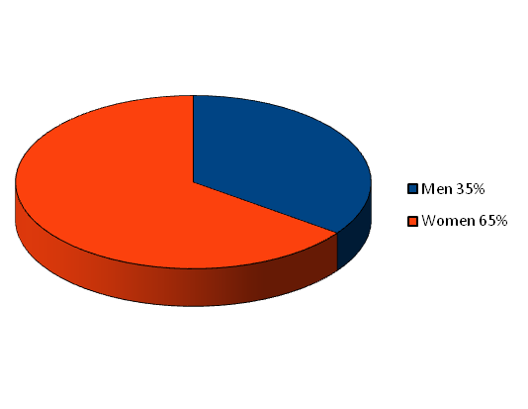
This chart shows how many men and women were referred into the service.
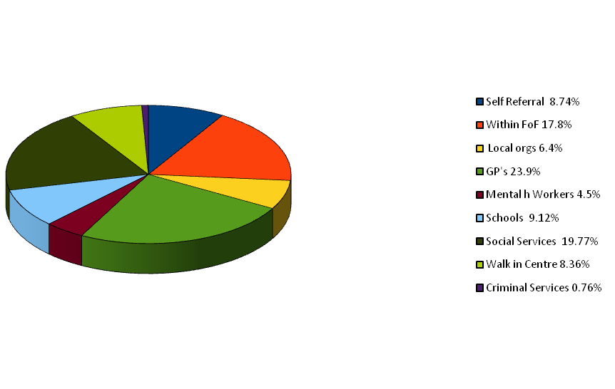
Referral rates into the FoF project over the life of the project, with GP's being the highest referrer.

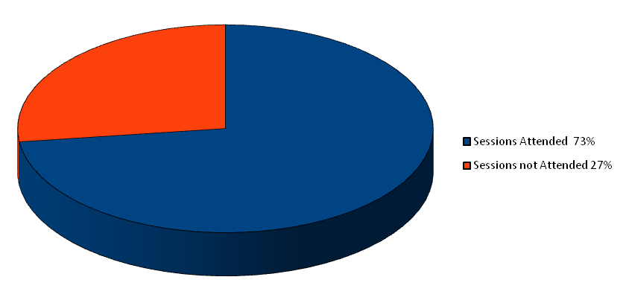

This shows the one to one sessions that were offered in Year One and the level of attendance. 1113 sessions were offered and attended by 812 people, making a 73% attendance rate.

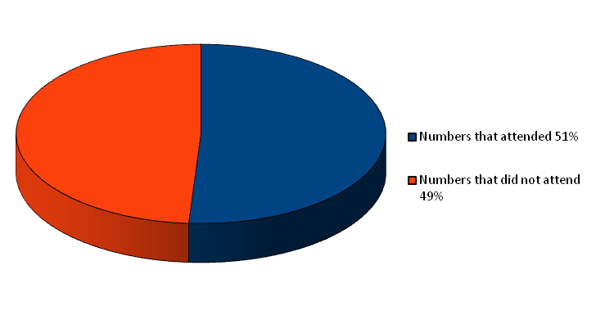

This is showing the group work attendance. Year One had a 51% attendance rate. The 51% attendance is made up of: Parenting Groups (41%), Psychosocial groups (36%) and taster sessions - Psychotherapy Group taster (12%) and Psychosocial taster (11%).

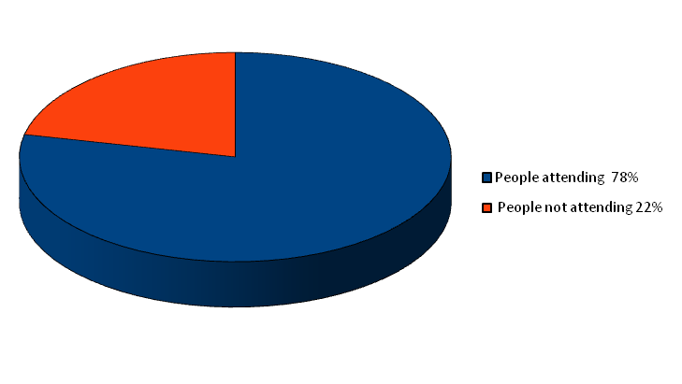

Year Two one to one sessions offered. 719 sessions were offered with 564 people attending, a 78% attendance rate.

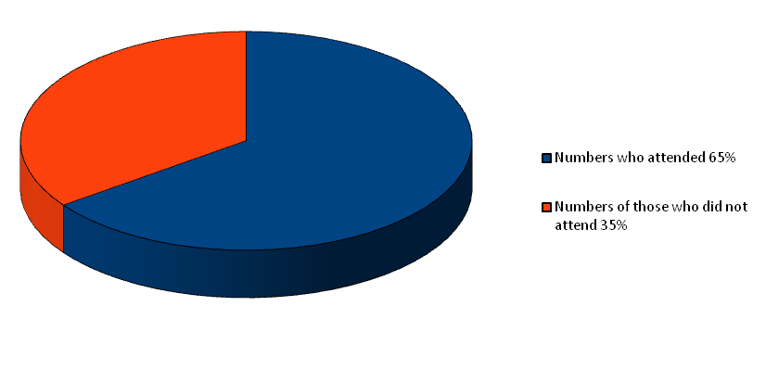

Year Two figures for group work attendance with a 65% attendance rate. The 65% attendance is made up of: Parenting Groups (69%), Psychosocial Groups (13%) and Psychotherapy Groups (18%).

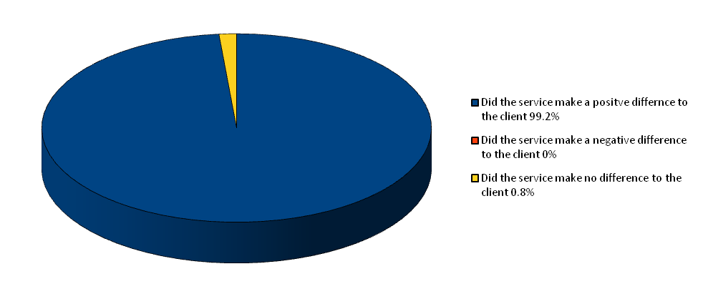

Clients were asked if the service made a positive difference to them.

99.2% said the service had made a positive difference
0.8% said it had made no difference
0% said it had made a negative difference to them

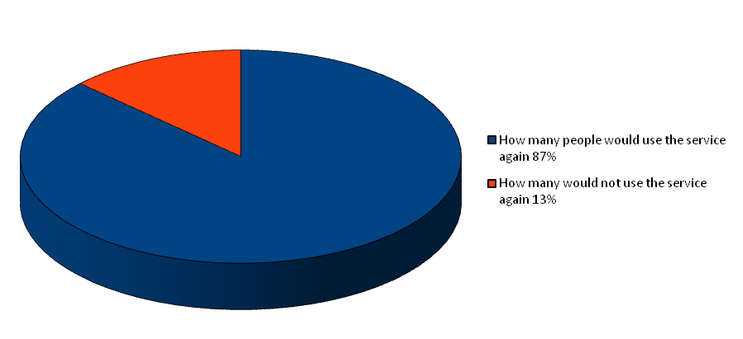

When clients were asked if they were allowed to use the service again 87% would use the service and 13% would not.

 | Year 1  (Feb 2010 to Jan 2011) | Year 2  (Feb 2011 to July 2011) | Average:
Reaching Communities  Outcome | Improvement % of completing clients | Improvement % of  completing clients
Health and Wellbeing | 63% | 82% | 73%
Family Relationships | 55% | 83% | 69%
Social Isolation | 73% | 90% | 82%
Behavioural Problems | 74% | 100% | 87%
Ability to Cope | 64% | 91% | 78%
Table showing improvement levels against Reaching Communities outcomes for Year 1 and Year 2

6. Case studies

Knowle West Health Park Company have been gathering information from clients who have used the Focus on Families services.

Client W:

W was referred to the service by her GP after visiting the surgery several times about feeling depressed. She is an ex addict (clean for 3 years) and has a young baby. She was feeling extremely isolated and felt “different” from other new mothers around her. She talked at length about her years of using heroin and how on the periphery of society she had been. She felt contaminated by her years of using and felt others would sense this and dislike her and avoid her. As she talked about her experiences over the weeks she described feeling “lighter”. She decided to try again to go to the local playgroup with her baby. She returned the following week excited and pleased at how well it had gone. W is approaching the end of her counselling and has also joined another community group and has started voluntary work in the local community. She says she is relating to her baby better and is enjoying life for the first time in years.

~~~~~~~~~~~~~~~~~~~~~~~~~

Client V:

V is a woman in her late forties whose daughter was recently killed in a road traffic accident. It was this experience that brought her into counselling. Clearly she was in a distressed state and feeling that she was unable to cope with life. During her counselling she spoke about the death of her mother when she was 8 years old. At this point she was put into care and family life, as she had known it, ended forever. She felt it was not just her daughter’s death she was grieving but her mother's too. V is still feeling sad but can also fundamentally cope with life rather than remaining on the edge and not coping or breaking down.

~~~~~~~~~~~~~~~~~~~~~~~~~~~~~~~~~

Client S:

S was estranged from his family (including his fiancé and children) as a result of a court order. He talked about how his relationship with his family had improved during counselling and he was on the verge of being able to return to the family home, both at the consent of his fiancé and the courts. Furthermore S reported how the counselling increased his ability to reflect on the impact of his behaviour upon others, and he was more able to consider the consequences of his actions. S was also able to revisit the loss of his father and was able to gain increased understanding about the impact this had upon his life. S was referred to the Anger Management course.

A Comment from a Social Worker

“…the families that I have referred for support through Focus on Families have reported very positive feedback. As a social worker it is getting more difficult to put services in place for families to help improve their situation and that of the child. I feel that the services and support that Focus on Families offers to families in Knowle West is invaluable and believe there will be a huge gap in services without the continued support of this service within the community”.

7. Cost Analysis

Financial analysis is becoming increasingly significant when measuring the impact and value of health or social interventions within communities. Unit costing, where the costs of individual interventions can be accurately reflected, has become the accepted tool used in commissioning processes.

Unit costs can be calculated by cost per person, cost per activity or cost per session. The cost of one to one services is inevitably higher than group activities and it is fair to say that the costs of more intensive activities, where a higher degree of support is required by users, is greater than lower cost, less intensive interventions.

Definitions of provision
- 1:1 Counselling: General counselling for a range of issues, delivered to men, women and families. Sessions are weekly for 1 hour each.
- Psychosocial groups: Short CBT-based courses providing information and practical advice on a range of mental health issues, including managing anger, depression, stress and anxiety. Groups run for up to 6 weeks, for an average length of 1.5 hours/week.
- Psychodrama 1:1: a method of individual psychotherapy for people aged 12+, incorporating creativity and drama-based techniques. Sessions are weekly for 1 hour each.
- Psychodrama groups: a method of group psychotherapy for adults, incorporating creativity and drama-based techniques. Psychodrama groups run for 7 weeks, for 1.5 hours each week.
- Parenting classes: Support and advice for parents on a range of parenting issues, within a group context. Parenting classes run for up to 10 weeks, for an average of 4 hours/week.
- Play Therapy: Specialised counselling for children and young people aged 3-16. Sessions are weekly for 45 minutes/week.

Cost of provision to Big Lottery Reaching Communities
Year 1 (Feb 10 – Jan 11) Lottery amt: £134,790.70
Intervention | Lottery investment | No of people seen | Cost per person | No of sessions offered | Cost per session | Cost per hour
1:1 counselling | 56612.09 | 103 | 549.63 | 855 | 66.21 | 66.21
Psychosocial groups | 2021.86 | 27 | 74.88 | 27 | 74.88 | 37.44
Psychodrama 1-1 | 9435.34 | 14 | 673.95 | 121 | 77.97 | 77.97
Psychodrama group | 673.95 | 35 | 19.25 | 3 | 224.65 | 112.32
Parenting classes | 57960.00 | 62 | 934.83 | 163 | 355.58 | 88.89
Play therapy | 8087.44 | 29 | 278.87 | 137 | 59.03 | 59.03

Year 2 (Feb 11 – July 11) Lottery amt: £56,880.00
Intervention | Lottery investment | No of people seen | Cost per person | No of sessions offered | Cost per session | Cost per hour
1:1 counselling | 29008.80 | 71 | 408.57 | 575 | 50.45 | 50.45
Psychosocial groups | 853.20 | 18 | 47.40 | 7 | 121.88 | 60.94
Psychodrama 1-1 | 2844.00 | 9 | 316.00 | 63 | 45.14 | 45.14
Psychodrama group | 1422.00 | 12 | 118.50 | 13 | 109.38 | 54.69
Parenting classes | 17632.80 | 17 | 1037.22 | 99 | 178.11 | 44.53
Play therapy | 5119.20 | 12 | 426.60 | 81 | 63.20 | 63.20

Why do costs vary?
There is great variation between the individual interventions as to the unit costs per person or per session. The variation reflects generally the intensity of the intervention and level of support required. The Barnardos process of parenting support requires in depth preparation and assessment prior to delivery of sessions so that the costs seem high, but the programme is arguably the most intensive within the Focus on Families range of service provision. Unlike other providers where KWHPC purchased sessions and some support costs, the Barnardos’ staff were employed full time on the project and thus on-costs were slightly higher too. In addition, all parenting classes include a crèche, with a minimum of two crèche workers, which adds to the overall cost of this intervention.

Overall service costs are comparatively higher in Year 1 then in Year 2, related to recruitment costs, purchases of necessary materials and equipment, and the launch of the project. Some costs were also deferred from the monitoring period, with a number of courses scheduled to run in the latter half of Year 2.

Overall service costs
Year 1 BIG Lottery amount £134,790.70
No of sessions: 1162 @ £115.99 per session
No of clients: 302 @ £446.32 per client

Year 2 BIG Lottery amount £56,880.00
No of sessions: 764 @ £74.45 per session
No of clients: 139 @ £409.20 per client

Value for money?
It is useful to apply a consistent model of calculating unit costs in order to understand the relationship between type of intervention and complexity of service being delivered. Compared to other interventions delivered by KWHPC, the Focus on Families services do have higher unit costs, for example in a UWE Evaluation of our activities on the South West Wellbeing Programme, Young People’s Play Sessions were costed at £3.29 per person and Pathways to Health one to one services were costed at £30.96 per person. However there is clearly a different level of intensity of support given, training, qualifications and experience required for delivering therapeutic and mental health sessions in an area like Knowle West. The level of complexity of need being dealt with by Focus on Families is much greater, and thus the interventions much more intense, than the low level interventions with children in active play sessions.

It can be hard to understand the cost of services in the context of money saved in future years. For example Play Therapy could positively influence the child so as to keep them in school, help them achieve better educational outcomes, therefore moving into work and keep them off benefits or out of the criminal justice system. There is no way to evidence the long term cost savings that the Focus on Families interventions might help make.

Comparisons with statutory services are also difficult to make, because it is hard to access data, the statutory sector often calculates costs without full overheads attached and it can be difficult to establish whether the comparisons really address like for like services.

Where unit costs have seemed high, KWHPC have worked hard with providers to address this. There has been some disappointment by the relative lack of success in engaging people in the groupwork programmes, leading to some groups being run “half full”. This obviously pushes unit costs up and in this sense it could be argued that groupwork has not been as cost effective as hoped for. However, it could also be said that it takes more time to engage clients in groupwork related interventions, due to the inevitable issues around confidentiality and building trust, which could partly explain both the lower take-up during Year 1 and the improvements in attendance during Year 2.

The one to one work delivered in Focus on Families was expected to be relatively expensive, having set out to employ well qualified, experienced practitioners with good support and supervision. This was important given the complexity of need in the area. It would be fair to report that one to one services were in line with the expected unit costs and given the outcomes achieved and the types of interventions delivered, can be said to represent good value for money.

8. Conclusion

In conclusion, the evaluation has been both a time consuming and rewarding process. While it was difficult, at least initially, to make contact with a representative sample of service users, most were only too happy to talk about their problems and why they had accessed the service once this contact had been made. Many were also so delighted with the service that they had received that it was a joy to talk to them and listen to their experiences.

Generally speaking, both clients and service providers would have liked more time for service provision. This was a common theme across the evaluation. Many stakeholders and service providers also commented upon the level of need in the area.

Historically, Knowle West is one of Bristol’s poorest areas and it has always taken a while for local people to get used to a service; unfortunately they are also used to services being taken away! This does not help with areas like Knowle West and a long term provision should mean just that. In my experience, it is rare to find high levels of attendance in a project being delivered in an area with such high indicators of deprivation. However, year two figures show that the numbers are increasing and with such positive outcomes these will only grow and show more results. Interestingly, the anger management service that is offered to both men and woman in Knowle West is the only anger management service in the whole of Bristol, at least that I am aware of.

Finally, it is apparent to me from the comments made by service users, partners and stakeholders that this project is a much needed service in the area. In addition, the number of referrals received by the Coordinator, as well as the uptake of services, appears to indicate that the Knowle West Health Park Company and the Focus on Families project are providing a service which is responsive to local need. It would therefore be a tragedy to lose this provision due to lack of funds.

9. Recommendations

Recommendation 1:
There needs to be some more work on the identity of the programme. Partner organizations need to be sure that they are letting clients know that they are on the Focus on Families programme. Most clients were unaware of the name Focus on Families.

Recommendation 2:
Consideration could be given to providing a questionnaire to each client at the end of their time with FoF to be completed. Given that people may struggle with reading and writing, a verbal questionnaire could be completed with each client. Whilst it is realized that this would be more work for each project provider, it is worth thinking about costing this into new contracts.

Recommendation 3:
An initial meeting of all new providers working with KWHP to attend a meeting prior to starting the project. This would reduce the initial confusion experienced by many new providers at the start of the project.

Recommendation 4:
As the cross referring seemed a little low it would be good practice to be sure that all providers are aware of what other services are available within the FoF project, to promote better cross referring.

Recommendation 5:
Background information about the area to each provider would be useful, whilst some organisations are very aware of the needs in Knowle West, some individual providers would benefit from some additional information.

Recommendation 6:
It may be worth pursuing the scope in any new funding bids to look at Tier 3 as this was bought up by a few of the providers.

Recommendation 7:
An assessment process would add great benefit to this project, particularly for those providers that get a high number of referrals. It may be worth looking at funds to employ an assessor to see clients and ensure they are suitable for the provider they are referred to.

Recommendation 8:
A weekly/fortnightly session with the project coordinator would benefit some of the providers. A telephone appointment would make sure each provider is up to date on a regular basis.

Recommendation 9:
Services need to be extended or made more flexible to be able to provide services for longer or enable the providers to extend the services on an individual basis. Some additional outreach support would assist with this issue.

- Appendix 1 - Partner’s details

Partner | Service
Ali Simmons | 1:1 Psychodrama Psychotherapy/Group Psychodrama Psychotherapy
Barnardos | Parenting Courses  Family group conferences
Butterfly | Play Therapy
Chris Andrews | Group Psychodrama Psychotherapy
GAN West | Men’s Counselling
Sue Jackson | Psychosocial sessions
Womankind | Women’s Counselling  Children and Family Counselling  Welcome Counselling (specialist service for women who have been sexually abused or raped)
- Appendix 2 - Client Quotes

When asked what difference the project made to them:

I now handle my bipolar better”
“I know I am not alone”
“It did help it is still helping me”
“I needed all the help I could get, it was wonderful to be around people and not feel lonely anymore”
“Letting go of my anger issues”
“I can laugh with my friends again”
“It has opened my eyes to a few things”
“I feel fantastic”
“So it's not just me”
“I can make decisions” (this was said with such glee)
“I isn’t so bad”
“Can I do it again?”
“Life is better”
“I think I am a stronger person”

When asked if their impression of the project had changed from one of apprehension:

“Everyone was so welcoming”
“I felt like I trusted them”
“I was shy when I started but I am not now in fact I think I am the loudest”
“I stayed and liked it more and more”
“Felt relaxed and welcomed and calm”
“I made new friends”
“It was brilliant how they made us feel right welcome”
“Just lovely”
“I was surprised how easy it was”
“Well it was brilliant”

We asked clients what the staff were like:

“Made you feel at ease and not guilty”
“Fabulous so supportive can't fault them”
“Brilliant fantastic lovely people”
“Yes they were great”

All clients questioned were asked if they would like to add any other comments:

What they do (KWHPC) is absolutely brilliant”
“My counselor was lovely”
“Someone said something about funding being available I would love to do some more”
“Keeps me out of Callington Road” (a hospital for people with complex mental health needs)
“Only one group in the afternoon would like more afternoon groups”
“Other people have noticed how much happier I am with myself”
“I loved my group and made some brilliant new friends”
“Found it brilliant”
“I think I am doing it all better now”
“It has made such a difference to me and my family”
“I can't believe how different I am”
“I will never forget them”
“Please put this in: I have always needed help but never asked, I will always ask in the future”

- Appendix 3 – Monitoring Tools

Each client was asked the same questions.
1. How long did they stay?
2. How were they referred?
3. Was there a wait?
4. Why did they access the programme?
5. What differences did the project make to them?
6. Would they recommend it to others?
7. What was their first impression?
8. Did this change at all?
9. What were the staff like?
10. Was there anything they did not like?
11. What would they like to see improved?
12. Were they offered any additional support?
13. What were they doing now?
14. Was there anything else they would like to add?

Each partner or stakeholder was asked the same questions, as follows:

1. What part of FoF did you provide?
2. How did you initially get involved?
3. What were communications with KWHPC like?
4. Was there sufficient support from KWHPC?
5. Would you work with KWHPC again?
6. What would you improve?
7. What went well?
8. Would you recommend KWHPC as a partner to other organizations?
9. Were the reporting systems accessible and easy to use?
10. How many clients were referred to your service?
11. Did you refer clients to other parts of the service?
12. Would you support the project if additional funding were secured?
13. Given funding restraints do you feel that the service you offered adequately met local need?
14. What else could you have provided if further resources were available to meet local need?

The number of clients listed in each table relates to those clients that have regularly attended services
The number of clients listed in each table relates to those clients that have regularly attended services

