Knowle West Health Park Company

Focus on Families
Evaluation Report 2013

Researched and written by
Helen Vines
VINESWORKS
enquiries@vinesworks.co.uk
www.vinesworks.co.uk

November 2013

info@knowlewesthealthpark.co.uk / 0117 377 2253


Contents

Snapshot of findings 3

Introduction 5
Focus on Families (FOF) 5
FoF+ 7
Knowle West Health Park 7

Methodology 9
Key stakeholders 9
Email questionnaires 9
Telephone interviews 10

Findings 11
Partners/Referrers 11
Managers 15
Workers 18
Clients 23

Recommendations/Conclusions 49

Appendices 50
1. Lists of stakeholder organisations 50
2. Follow-up progress from previous evaluation 51

Snapshot of Findings (taken from these specific consultation findings, rather than total stakeholders engaged with FoF over its 3 year life).


Partners/referrers praise FoF for delivery team, speedy responses, positive partnership working and the range and quality of services
100% of partners/referrers are positive about FoF referral process.

100% of partners/referrers rate the referral packs as positive

Majority (54%) of partners/referrers said their dealings with KWHPC in relation to FoF were “excellent”.

Majority (77%) of partner/referrers said clients had given positive feedback about their experiences of FoF.

SLA Managers praise KWHPC staff, good communications, excellent facilities and high quality accessible, effective support services.

All delivery partner agencies 100% would work with KWHPC again

100% SLA Managers were happy to recommend KWHPC as a partner.

FoF Workers feel FoF’s range of services is appropriate to local need but should be on a longer-term basis to make a lasting difference.
100% FoF workers thought communications with KWHPC were positive.

100% FoF workers felt KWHPC had got it right in terms of client progress monitoring.

75% FoF workers thought FoF services had benefitted the client group.

Clients’ use of services ranged from a single meeting to taking up several courses over several years.

60% of clients used 2 or more services

92% (23) of clients thought the length of time they used the services was “about right” for them at that time.

Clients had a wide range of entry points into FoF services.

96% (22) of clients who expressed an opinion were satisfied with the initial response they got from KWHPC once referred.

On average, 77% of clients thought that clarity of information received, length of wait to receive the service and availability of appropriate services was “good”. A further 21% thought it “satisfactory”.

Only 1 client voiced a negative opinion, reiterating the view that they had “waited quite a while for an appointment.”
100% (25) of clients thought the FoF services were helpful

95% (19) of clients for whom it was relevant had a positive change in terms of their own Health and Wellbeing.

90% (18) of clients for whom it was relevant had a positive change in terms of their own family relationships.

95% (19) of clients for whom it was relevant had a positive change in terms of their ability to cope with day-to-day life.

69% (9) of clients for whom it was relevant had a positive change in terms of reduced social isolation (ie. getting out and meeting more people)

88% (15) of clients for whom it was relevant had a positive change in terms of reducing behavioural problems (ie. solving problems/dealing with things better).

No client reported a negative change in any of the outcomes as a result of having used FoF services.

For all FoF+ outcomes, a positive change was reported across the board, with only 1 instance of there being no change in terms of the client’s health and wellbeing.

No client reported a negative change in any of the outcomes as a result of having used FoF+ services.

100% (25) clients were positive in describing how they were treated by KWHPC staff.

64% (14) of clients who answered the question had other services suggested to them by FoF workers.
100% (25) of clients said they would recommend FoF to family and friends.
Introduction

This report follows up on a previous evaluation which covered the first year of the Focus on Families project (February 2010 – July 2011). The project is managed and delivered from Knowle West Health Park (KWHPC), working in partnership with a range of partners.

This report looks at the level of take-up of services through Focus on Families (FoF) and, through telephone interviews with a cross-section of users, seeks evidence to demonstrate whether FoF is helping users to make positive change for themselves in the following areas:

- Improving mental health and wellbeing
- Improving positive family relationships
- Reducing social isolation
- Improving ability to cope
- Improving behavioural issues.

The FoF management team were keen to see if FoF was helping people to build up their “resilience” to be better able to cope with life and crises as they arose. They were also keen to explore with partner agencies and delivery sub-contractors how partnership arrangements were perceived to be working and if there were any ways to increase cross-referring between FoF services.

Background
Focus on Families (FoF)
Focus on Families was initially a three year project, funded through the Reaching Communities programme of the Big Lottery. KWHPC was subsequently successful in attracting a further three years funding from BIG Lottery, so the project is now in its fourth year of delivery.

The project is co-ordinated and hosted by KWHPC with most services being delivered at the Health Park. Services are delivered through service level agreements (SLA) between KWHPC and organisations such as Barnados and Womankind, and with qualified, experienced professionals. See Appendix 1 for full list of delivery partners, referral agencies and FoF Workers.

Focus on Families aims to support people with mild to moderate mental health issues. This includes families who are struggling to cope, or in conflict, and individuals who may be dealing with the effects of bereavement, violence, abuse, isolation and other traumatic events. It does this through provision of a range services, including:

- General counselling for individuals and families (in areas of health inequality only)
- Play therapy for children and young people (in areas of health inequality only)
- Parenting workshops and courses
- Psychological education course on topics including anger management, coping with stress, anxiety and depression
- Therapy groups (Making Changes)
- Counselling for men and women who’ve been sexually abused/raped

Services are free to the user and offered in a confidential setting.

FoF was set up in response to the high levels of deprivation including mental health issues and number of vulnerable adults and children, living within Filwood Ward in Bristol. The evidence showed that families are often trying to cope in isolation, lacking support from family and friends. Historically, the services which do exist are often inaccessible because they are not local or the provision is available for acute problems only.

The Joint Strategic Needs Assessment (JSNA) 2008 identified the following health inequalities facts for Filwood ward which provided underlying evidence for the need for FoF:
- In top 2 wards for numbers of children with mental health disorders
- In top two wards for % of children in care 2006-7
- Its young people are in the highest rank ward for vulnerability to substance misuse
- It had the highest cancer mortality rate for Bristol between 2002-06
- It is in the top five wards for numbers of people living with limiting long-term conditions
- It is in the top two wards for the numbers of people claiming Disability Living Allowance.

More recent data reinforces the continued need for the project.

- Average life expectancy in Filwood is 76½yrs, in Henleaze it is 85yrs. (JSNA baseline data 2012)

In a recent Quality of Life (QoL2013) survey for residents self reporting that their health has been good in the last 12 months, Filwood is the 3rd lowest (out of 35) ward in Bristol. The same survey also came out with the following results:

- Filwood is second highest ward of households which have a smoker living there.
- Filwood is 6th bottom for residents who eat 5 portions of fruit and veg per day.
- Filwood is the ward with the highest rate of obesity.
- Filwood is the third lowest ward for satisfaction with life.
- Filwood has the lowest level of participation in creative activities.
- Filwood has the lowest rate of respondents who think that people treat other people with respect in their neighbourhood.
- Filwood is the second lowest for rates of internet use.
- Filwood is the second highest for rates of people with no educational or technical qualifications.
- Filwood is the fourth highest for rates of people on means-tested benefits.

FoF+
In addition to the FoF programme, Focus on Families Plus (FoF+) is a partnership between the South Bristol CAF Team (SBCT) and Knowle West Health Park Company’s FoF service. The aim is to improve the emotional health and wellbeing of young people, parents and families in South Bristol who’ve had a Common Assessment (CAF), by providing the following services for free:

- General counselling for individuals and families
- Play Therapy
- Coping Skills Groups for Young People and their Parents/Carers

All of the services are intended for individuals and families who are suffering from mild to moderate mental health issues, including the effects of abuse, bereavement, family conflict, social isolation and other traumatic events. All services are confidential. This report includes feedback from a small number of clients who received services via FoF+. To the end user, there is no obvious difference between the FoF and FoF+ offerings.

Knowle West Health Park Company (KWHPC)
KWHPC is a charitable company created to tackle health inequalities and promote health and wellbeing. The company provides high quality services to prevent illness and promotes good health and recovery after medical treatment. Most of its directors are local people, who have an extensive knowledge of the local area and the issues effecting local residents. Also on the board are representatives from local partner groups, health professionals as well as NHS Bristol and Bristol City Council.

KHWPC has a Chief Executive Officer and staff team to plan and deliver services. Volunteers also contribute to the work of the company across a range of areas.

FoF Services started in February 2013 and a report is available covering the findings from the first year of activity (contact KWHPC for a copy: Evaluation Report, Focus on Families by Mandy Shute, 2011). Recommendations from this report and the KWHPC response to them can be found in Appendix 2.

An extract from the End of Project report to the Big Lottery (June 2013), written by the Project Manager, summarises some of the outcomes and outputs of FoF.

“The Focus on Families project went from strength to strength over the initial three years of funding as the project became more widely known, with increasing numbers of referrals and beneficiaries using its services. A total of 1102 individuals across a range of services accessed the project by the end of Year 3 (January 2013), with a further 1434 indirect beneficiaries. Furthermore, it was evident by the high number of referrals received (approximately 1800 across all services) that there was, and continues to be, a significant need for people to be able to access local, responsive and effective community support services.

Referrals came from a wide mix of agencies, including schools, GP surgeries, Children and Young People’s Services, Adult and Child Mental Health Services, local community organisations, Avon and Somerset Police as well as self-referrals. The number of referring agencies almost doubled from Year 1 (22) into Year 3 (42).

The project was also effective in terms of delivery outcomes. At the beginning of Year 1, each service provider forecasted a level of improvement they expected to see through the delivery of interventions addressing the five outcomes. This ranged between 50% and 80% of clients reporting an improvement, depending upon the intervention. The final improvements are similar to those reported in the initial funding bid, for example:

71 % reported an improvement in their health and wellbeing
67% reported an improvement in their family relationships
72% reported a reduction in social isolation
68% reported a reduction in behavioural problems
72% reported an improvement in their ability to cope

Furthermore, we are aware through anecdotal evidence that the service became a good treatment option for local GP’s and health and social care professionals, helping to reduce the pressure on statutory resources at a time when many services were being cut and/or needed to make efficiency savings.”

Methodology

Following meetings with the FoF Co-ordinator and KWHPC CEO and the evaluator, an action plan was drawn up.

The scope of the evaluation was to cover Years 2 and 3 of the project. Key stakeholder groups were identified and it was agreed the following groups would be consulted for their views on aspects of the project.

Stakeholder group | Consultation method | Number consulted | Number of responses
Managers of service level agreements | email/online questionnaire | 8 | 4 (50% return)
FoF staff/workers | email/online questionnaire | 12 | 8 (67% return)
Partners/referrers | email/online questionnaire | 25 | 16 (64% return)
Users (sample) | telephone interviews | Initial target 50, revised to 25. | 25

The Year 1 evaluation had focussed on outcomes for users. For this evaluation the KHWP CEO and FoF Co-ordinator wanted to explore partnership working and how delivery partners and referrers to the FoF services found the process, in addition to seeking the views of a small sample of users to find out if they felt the services they used enabled them to create change for themselves.

Email/online questionnaires
45 stakeholders (initially identified for inclusion by the KWHPC CEO and FoF Co-ordinator) were invited by email to complete a short online questionnaire. These comprised 3 groups of people:
- Managers of service level agreements held with KWHPC to deliver FoF services.
- Workers delivering the services, either through service level agreements or as private contractors.
- Partners/referrers: stakeholders from a range of organisations who work in the same arena as KWHPC, and who refer clients into the FoF services.

See Appendix 1 for a full list of organisations who were invited to give their views under these categories.

Overall for these 3 groups 28 people responded, a response rate of 62%. Of the other 48% some emails bounced back, other automated replies indicated people were on maternity leave, jury service, had left their post and some emails were “deleted without being read”.

Telephone Interviews
A list of 95 names and numbers of clients who had indicated they were happy to talk about their experience of using FoF services was compiled from the KWHPC database. Actually getting in touch with people proved harder than anticipated. As the lists were compiled from a range of services, there were a number of duplicate names as some people used more than 1 service. Taking out the duplicates reduced the number of possible clients to 75. Three clients on the lists had no contact numbers leaving 72. Three contact numbers did not have sufficient digits. For six contact numbers the line was dead, and for a further six the number was “not recognised”. On one landline calls were “not being accepted”. This left 56 contact names and numbers.

In addition, anticipating the best time of day to catch people whilst they were in, and available to talk, was not simple. The KWHPC CEO and FoF Project Manager instructed that, due to the sensitive nature of issues some of the clients are facing, no answer machine messages should be left, nor explanations given or messages left with other people who answered the phone if the client was not in. This further reduced the “hit” rate with 17 “no replies” or answer machines, even with repeated attempts on different days. Two clients were out and no message was left. This reduced the possible contacts to 38. However, when contact was made with the client, and the explanation for the call was given, nearly all were happy to share their views and only three people declined to be interviewed, one saying she was about to go out, and two saying they couldn’t really remember much about it. In total 25 were interviewed, the majority during the week but also a few at the weekend.

The original intention was to hold a series of further detailed interviews at KWHPC with up to 10 clients who were happy to talk in more depth, about their experiences of FoF. In reality after the phone conversation, most people were happy that they had said all that they wanted to and didn’t feel they had much to add at a face-to-face interview.

Findings

Stakeholders - Partners/referrers.

1. 16 people replied to the consultation. Respondents were drawn from a range of organisations including Health Care Trusts, Public Heath, Probation service, KWHPC, Children and Young People’s Services (CYPS), Children’s Centres, Doctor Surgeries, School and CAF Lead Professionals, Voluntary Sector Organisations and a Neighbourhood Partnership.

2. Roles within those organisations were various, including: health visitor, probation service worker, social worker, project managers and co-ordinators (CAF and Family Services), school and family link worker, facilitator, Pathways to Health co-ordinator, GP and health trainer.

NB: although 16 people responded, not everyone answered every question.

FoF and referrals
100% of partners/referrers are positive about the FoF referral process.

3. Stakeholders were asked how they found the FoF referral process, in terms of ease of use. No-one thought it “poor”. One person thought it “satisfactory”, 2 thought it “good” and the majority (9) thought it “very good”, with 3 people describing it as “excellent”. One person thought an electronic system would be better. One person did not answer (dna) as they had never used the referral process.

Comments:
“The referral form is slightly long, though appreciate you need the info. I used to find the tear off pad for the KWHPC easier.”

“We often get updates on what is being offered and there has been changes to the referral form that we were updated about - so good communication, however the documents detailing courses or referral forms etc are often not dated so it is difficult to tell which is the updated version. It would be helpful to have something like Version 5. Feb 2013 as a footer on documents.”

100% of partners/referrers rate the referral packs as positive

4. When asked to rate the referral information contained inside the referral pack, the response was 100% positive, with 5 people saying it was “good”, 6 saying it was “very good” and 4 describing it as “excellent” (the person who had not used the referral system dna). A suggestion was made that “it be in a coloured booklet so that clients may be more likely to read it.” Another person stated that “xx had put together a pack that was more user friendly to our families”. Someone also commented that “we get frequent email updates of courses running”.

Majority (54%) of partners/referrers said their dealings with KWHPC in relation to FoF were “excellent”.

5. The response was also 100% positive when stakeholders were asked to think about their interactions with KWHPC in relation to FOF: 2 said it was “good”, 5 said it was “very good” and 8 (54%) said it was “excellent”. One person commented that the “regular team meetings are very useful” (One person dna).

FoF and outcomes

Majority (77%) of partner/referrers said clients had given positive feedback about their experiences of FoF.

6. Stakeholders were asked if they’d had any feedback from people they had referred to FoF about whether they had found the services useful to them. 16 people answered with the majority 77% (10) of those who had received feedback saying “yes”, and 23% (3) having had a “mix of opinions”. Three people said they had not received any feedback.

Comments:
“I have referred a number of families for support from FoF and I have been advised that they have found the service very beneficial”

“yes beneficial, and some of them would have liked more sessions”

Improving FoF

7. Stakeholders were asked for suggestions about how KWHPC might improve the FoF service for clients. 8 people offered suggestions. These included the need to increase reach through; eg. advertising the service through schools and perhaps using minibuses to get children to sessions to counter the perceived barrier of some parents, word of mouth from service users, and using community venues which are seen to be accessible; to extend the catchment area (2 comments) and extend provision eg. more counselling and anger management provision. One person highlights the perennial problem of short term funding and the importance of “keeping going”. Fortunately with continuation funding now in place the momentum of 3 years of FoF will not be lost.

“Maybe clearer communication between referrer, referred, and therapist initially so that families understand and recognise who and why they are being contacted and offered a service by - sometimes families don't make the connection between the appointment letter/call and the conversation they had with the referrer.”

“Advertise through schools more”

“I feel that it maybe good to have a minibus to pick up children from their homes to come to the services as I find that some parents are a barrier to children accessing the services you provide”

“Venues that are community based - easily accessible.”

“The process is simple for all to use and we haven't experienced any issues.”

“As yet I haven't had that many families who have gone through the referral system as yet so I am unable to comment.”

“The only thing that is difficult and I understand this is due to funding is the small area that FoF cover”

"More Counselling sessions.”

“Anger management is always in short supply and very intermittently provided“

“Extend the catchment area (if possible)."

“Keep going! as it takes ages to spread the word. Lots of things in Knowle have just got going and then they pull the plug on funding. Word of mouth between families who you have helped will be enough, but it doesn't happen overnight or even 3-4 years!”

8 Anything else?
Praise given to FoF for delivery team, speedy responses, positive partnership working and the range and quality of services

Respondents were invited to make any other comments about FoF. All were positive and touched on the range and quality of services offered and the delivery team, benefits to clients and the proven need for the services, the speedy response of FoF staff and the positive partnership working.
“It's great news that these services are now available to families across south Bristol, rather than just Knowle.”

"I am aware that Limara, Garth & Eileen have been liaising and working together to improve service delivery - numbers.”

“I am also aware that service users/CAF team appreciate Chris's flexibility."

“We find this a very helpful service, easy to refer to and people generally get offered a service quickly.”

“I work in the duty team at Broadwalk and I know that all the social workers within the team make referrals to FoF. Without this service there would be a huge gap in service provision for supporting families.”

“This is an excellent project which is beneficial for our clients. The Coordinator and staff are good and do respond to inquiries swiftly.”

“I wish we had something like this where I live, I'd love to do some of the courses.”

“Very satisfied with the service from start to finish. Very good staff.”

Findings

Stakeholders - Managers

This group of stakeholders are managers who hold service level agreements with KWHPC to deliver services under the FoF umbrella.

Eight people were consulted, 4 replied to the consultation

1. Working with KWHPC

SLA Managers praise KWHPC staff, good communications, excellent facilities and high quality accessible, effective support services.

Managers were asked what had worked well? Responses focused around three key topics:

- The high quality of KWHPC staff and positive communications with them, which enabled effective partnership working. This was seen to be across the organisation with ”very good leadership, culture and environment for staff and service users.” One manager appreciated the “honest dialogue when things were difficult” and staff were seen to be “genuine and easy to talk to”, “friendly, supportive and responsive”.
- The suite of community support services being offered by KWHPC, which was seen as “high quality, accessible and effective”.
- Use of KWHPC facilities to deliver services. This was much appreciated, being cited as “an excellent resource”.

"Park staff are genuine and easy to talk with, they are relaxed and interested in us.”
"Excellent partnership working and a mutually beneficial arrangement.”
“Staff are always friendly, supportive and responsive”.
“Good communication (and other) systems in place which has enabled us to work effectively together”.
“Working autonomously, but supported well by the line manager.”
“Very good leadership, culture and environment for staff and service users.”
“They respond quickly to emails and calls.”
"Honest dialogue when things were difficult.”

“It was easier for us in how they dealt with the waiting lists and referrals."
“Provision of high quality, accessible and effective community support services."

“The room for play therapy is perfect!”
“Use of the KWHPC building for some of our activities, it was an excellent resource."
Three SLA managers feel communications can be further improved.

2. Managers were asked what they would improve, and how? One manager would like to have more use of the KWHPC building. When it was not available they sometimes found it difficult to find a suitable alternative.

The three other comments were all related to communications in some way: one person felt “things were said that were unclear” and she/he “was at times very unsure of my role”. Two people specifically referred to the monitoring process with one saying it “seemed to change each quarter, which left me feeling confused and stupid”. Another thought it would have been “helpful to have clearer systems at the start to reduce the need for changing reporting requirements mid way though projects, creating confusion and additional work”. A third person suggested an extension to the peer supervisions meetings to enable time to exchange views about work in progress.

"Sometimes the communication was very frustrating. Sometimes things were said that were unclear and at times I was very unsure of my role. The way monitoring was done seemed to change each quarter, which left me feeling confused and stupid.
At one point my therapist had written a case study thinking that it was for the lottery but it was widely circulated."

“I feel there should be an extension of the peer supervision meetings to enable us to have time to exchange views about our work in progress.”

“The monitoring process is quite extensive and it would be helpful to have clearer systems at the start of projects and to have a shared understanding by all parties in relation to what is required. This would reduce the need for changing reporting requirements mid way through projects which creates confusion and additional work.”

“More use of KWHPC building - when we did not have access to it, we sometimes found identifying good alternative difficult.”

Opinion split on reporting systems being accessible and easy to use.

3 & 4 Managers were asked what were communications with KWHPC like? One thought they were “satisfactory, one said “good” and two said “very good”.

Respondents were split in their opinions about whether the reporting systems were accessible and easy to use. Two said “yes” and two said “no”, their reasons being outlined above. That said, there was recognition that this issue had been worked on and that hopefully it would be better from this point onwards.

“They constantly changed! At times it was unclear. This has been worked on and I'm hopeful that (although changed again) it will be easier from hereon in.”

“Reporting systems are not exactly difficult to use, however there have been issues as stated above.”

All delivery partner agencies 100% would work with KWHPC again

5 & 6. Managers were asked “do you feel the SLA adequately described your responsibilities as a partner in this project?” All four respondents (100%) said “yes”, reflecting the work done at the start of the project in establishing these contracts and ensuring clarity within them. Likewise all four (100%) said they would work with KWHPC again, with one person commenting: “the Goods well outweigh the Frustrations!”.

100% were happy to recommend KWHPC as a partner.

7. All four respondents (100%) were also happy to recommend KWHPC as a partner to other organisations, with one manager commenting: “We have had a very positive experience in working with KWHPC and are pleased to be involved with the organisation.”

Findings

Stakeholders – FoF Workers

Twelve people were consulted, 8 replied to the consultation.

1. The eight respondents have been involved in delivering a wide range of services through 2012/2013. These included group and individual work. Their work covered the full range of FoF services with the exception of the Parenting Course and the Dealing with Depression course.

2. KWHPC is interested to explore the extent to which clients are cross-referred into other services. So the question was asked: “Over the last 12 months, how many individual clients did you refer into the following FOF services?”. All 8 workers answered this question.

The graph below shows how many individual clients, over the last year of the project, were referred to other FoF services by the 8 respondents.

The figures are relatively modest. It may be that the client is in the correct service and others are not as suitable. However, clients who have used more than 1 service have talked of the benefits of this, for them and their wider family.

100% FoF workers thought communications with KWHPC were positive.

3. Workers were asked “what were communications with KWHPC like?”

100% of respondents (8) were positive with one person commenting “I appreciate the support I have received from my line manager”. Two said it was “good”, four said it was “very good” and two said it was “excellent”.

Background. KWHPC co-ordinates FoF, being a central point of contact for stakeholders, subcontractors and referrers, as well as managing the direct relationship with the BIG Lottery as the funding body.

Each subcontractor is given a time-limited SLA which stipulates the type, amount and description of the service being contracted. The cost of that service is specified, including costs to cover administrative or monitoring duties. SLAs also detail specific requirements around training and qualifications, supervision, insurance, CRB checks.

Line management of the frontline workers remains with their employer, who also provides clinical supervision, ongoing support and professional development. Evidence of this is required before the SLA is finalised. Performance is monitored against the SLA, using data submitted by each subcontractor on a quarterly basis.

KWHPC believe that using a range of sub-contractors supports the ethos of client choice and allows greater flexibility of response to client need. It also affords an opportunity for the development of group learning within the network of subcontractors. To this end KWHPC hold quarterly peer group meetings, attendance at which is mandated in the SLA, where practitioners from the range of different agencies can come together to talk about their experiences, what works or does not work and how to overcome barriers or difficulties. This is the model KWHPC has developed to support their relationships with sub contractors, and they have found it to be beneficial both to KWHPC but also to the sub contractors involved. KWHPC also holds regular management meetings to look at overall service development, outcomes and performance, and to talk about how improvements could be made for future delivery.

100% felt KWHPC had got it right in terms of client progress monitoring.

4. Workers were asked what they felt about the amount of monitoring of client progress. Unanimously all eight said they thought it was “about right”. That said, one person felt “some of the questions are a misleading” but didn’t detail which. Another person commented thus: “The monitoring of client progress I guess is to get funding so it is needed, and I suppose it lies with the funders how much monitoring they need to make a decision about how effective the service is. Sometimes the monitoring questions are not really suitable (i.e. age related) for the clients I work with.” It seems interesting that the worker perceives the value of monitoring to be primarily to secure funding and less to measure the progress of the client in creating positive change for themselves.

75% thought FoF services had benefitted the client group.

5. Workers were asked to think about their interactions with clients and other service provides, and consider to what extent do you think FoF has benefitted the client group? 50% (4) of respondents said “very well/exceptionally well”, 25% (2) said “to some extent” and 25% (2) said “it depends” – the main caveats seeming to be a) the complexity of issues being presented within a target group so it is patchy across the group, and b) the amount of time workers can give to people with long term problems, and lack of opportunity to consolidate positive change. This is reflected in some client feedback who said there was positive change at the time but now feel they are “sliding back into old habits”.

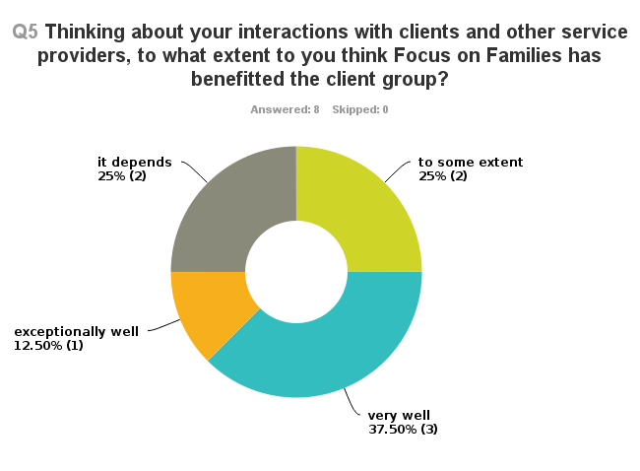

“Their anxiety levels have lessened and their coping skills increased.”

“The cases referred to women’s counselling and family therapy are often very complex and complicated and therefore it is patchy as to whether the client group has benefitted.”

“Some families who engaged with the play therapy, and whose problems were not too entrenched, have benefitted from the short term help on offer, but it is very limited by the time constraint. Where relief has been obtained there has not been enough time to consolidate it into something permanent, and for those whose need is greater the time limit turns the help into something tantalising and unsatisfying.”

“Some of the clients we work with have had problems for a very long time. There is only so much that we can do in the time we have with them. “

“As far as children's mental health goes I think many children, parents, schools, G.Ps and CYPS have appreciated this service since it provides support when a child's mental health isn't severe or complex enough to reach the CAMHS threshold yet it is impacting on their quality of life and emotional well being. Many women whose children or families I have worked with have commented on how useful having women's counselling has been.”

Workers feel FoF’s range of services are appropriate to local need but should be on a longer-term basis to make a lasting difference.

6. Workers were asked whether the range of services provided by FoF is appropriate to local need? Of those that had an opinion (5), 100% said “yes”. A further 3 were unsure. They were positive about the FoF offering but had reservations in light of limited resources to work over a longer period with clients.

“Linked to the question above - I think that the services identified by Focus on Families are appropriate for local need - however, what hampers the effectiveness of the service is the brief nature of the work.”

“The range of services seems very helpful, especially the parenting and support aspects, but the counselling services need to be responsive to need rather than a predetermined short limit.”

“In an area of deprivation, there is always more that could be done if you have the time and resources (especially money)!”

7. Workers were asked: Did “any of your clients have specific needs which could not be met through Focus on Families?”

50% (4) answered “yes”, 1 was “unsure” and 3 said “no”. Their explanations for their responses are given below and relate to timeframes, absence of a potentially useful service (mentoring for young people), and very specific client needs. The comment was also made about parents not engaging and thus the needs of the child not being met. Working more directly through schools might address this latter point to some extent.

“For some young people, a mentoring service would have been invaluable”

“Linked to the two preceding questions I think that the clients’ specific needs were not always met because it was not possible to do this in time available.”

"Some required referral on to CAMHS, others had medical or educational needs. The clients who did not engage did not get their children’s needs met"

“This is a bit of an ambiguous question and I'm not sure how to answer.”

”I work with groups where I do not require that people tell me a great deal about their personal history or current presenting problems. It's therefore a hard question for me to answer. Some clients have said that there were some things that they would like (such as a DBT programme) that FOF is not set up to offer at the moment.”

8. Workers were invited to offer any other comments.

“I think that the involvement of the lead professional can have an impact on the client’s ability to engage with the work.”

“The clients who came to me were referred via the CAF panel only”

“FOF is a unique project offering something for every member of the family/community. Group work is rarely that popular, so I think the majority of the real work with clients is done by the counsellors with the psycho-educational workshops being available as a useful adjunct.”

Findings

Stakeholders - Clients

Twenty five clients were interviewed on the phone. In some instances they and their children/grandchildren had used FoF services, bringing the total of service beneficiaries encompassed by this report to 32.

Collectively, clients interviewed had used FoF services throughout the duration of the project, from early 2010 to March 2013. Only 1 person couldn’t remember when they’d started to use services.

Clients had used whole menu of FoF services, except Mindful Living

Clients interviewed had, between them, accessed all services under the FoF umbrella, with the exception of the Mindful Living course (nb. this service was used during the lifetime of the FoF project, but the evaluator was not able to contact users of this service). This range of take-up of services does not seek to accurately reflect the actual levels of service take-up over the life of the project, or indeed in the period covered by this report. However it does illustrate that the views contained in the following pages include at least one service user’s perspective on each of the FoF services, with the exception of Mindful Living.

60% of clients used 2 or more services

Of the 25 people interviewed, 10 (40%) clients used one service only, whilst 15 (60%) clients accessed two or more services under the FoF umbrella, and other activities underway at KWHPC. This was the intention when FoF was put in place, that individuals could access a menu of services that complemented each other, under the same roof. Several clients commented that they started using one service and from that heard about other services and then made use of those too.

The following chart illustrates the services the 25 respondents used.
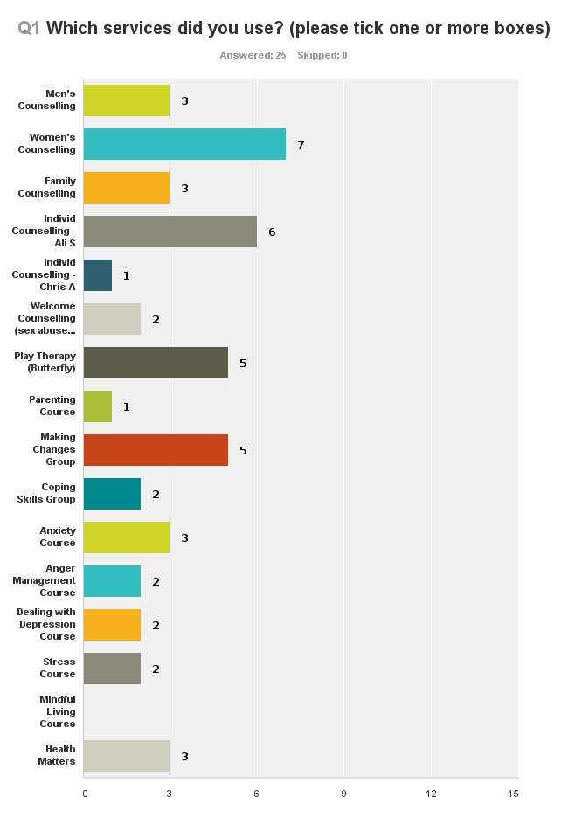
Ten respondents also cited other KWHP services that they used, including:

- Arts Class (4 respondents)
- “Beauty course, plus we attended a CAF course in Filwood for Mothers and Daughters” (1)
- The Crèche (2) “The Crèche meant I could do the courses, but was just next door to my child if I was needed”. “The crèche was invaluable and brilliant. I wouldn’t have been able to use the services without it”
- Fit and Fab (4)
- Pathways to Health (2)
- “Reflexology, acupuncture, lots of things!” (1)
- Tai chi (1), and another client is about start the class (1). The person who had done tai chi commented: “I really loved it but I can’t afford the bus far across to get to the classes”.

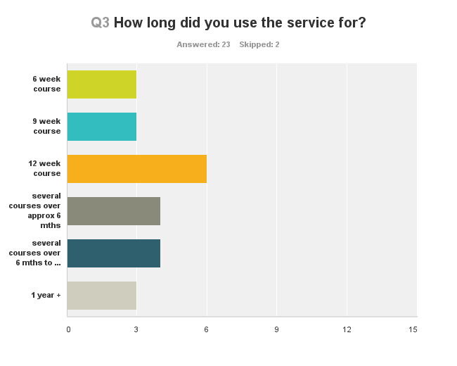
Clients’ use of services ranged from a single meeting to taking up several courses over several years.

23 clients answered this question. In addition to the pre-given options above, 1 person said they’d attended the Welcome Counselling for 6 months.

The level of take up of services varied hugely across the clients, illustrated by the following comments: “I was only seen once, as at the time I wasn’t sure whether it was best for me, but there was an opportunity to be seen again”.

Conversely others have taken good advantage of the range of FoF services, being able to pick and choose from a menu that suits their needs and personal preferences: “I finished the Making Changes course and absolutely loved it. I did a couple of sessions of Counselling but didn't really feel it was for me. I've done other classes since (around Pathways to Health) and would like to do another Making Changes course if they're still running”.

Another said: “I’ve been at the Art Group for a while now. And I'm now on my third round of the Making Changes group as I find it so useful. I've also had some 1-1 counselling arranged via the Art Group, I'm dealing with lots of anger”.

A mum commented: “Signed up for Coping Skills course. Only came a couple of times, my son didn’t like it and wouldn’t come. We did Family therapy (counselling) for 10 months.”

And a fourth person commented: “I’ve done a range of courses and classes for over 2 years now. First I came for counselling with Sally after my stroke. She introduced me to the Art Class bit by bit and came with me at the beginning. I'm now learning to bake bread and bring my husband along. I still get frightened in larger groups, there are too many in the Art Class”.

A lady who had individual counselling said: “I did consider the group pop-in/drop-in about women in distress. I ruled out going there because I didn't want to surround myself with people in similar distress. I'm in recovery and didn't want to put myself back by being with people doing over the same stuff. Am trying to be positive and move forward.”

Sometimes day-to-day life and crises got in the way of respondents attending more courses, eg. “We went 4 or 5 times then my son got really poorly, was diagnosed with autism and started having absence seizures so other things took over”. Another respondent who had attended several courses and was due to attend another commented: “I had a car accident and didn’t manage to make it to the last course. I feel bad about that”.

92% (23) of clients thought the length of time they used the services was “about right” for them at that time.

2 clients felt it was “too short”, with one making this observation:

“It was too short. It takes time to get to know the counsellor, you're just getting into issues and then it's over. I didn't get on with first counsellor, I cried a lot and felt very uncomfortable. Then came back again and clicked with the second one. I got on much better with her. Came with my daughter.”

In total 7 clients made additional comments, some comments highlighting the complex nature of issues people are facing on a day-to-day basis. One person commented thus, and similar sentiments were heard several times during interviews with other clients.

“”About right” at the time when I was having a bad time and I wasn't coping so well. After the courses I did well for a while and now may be needing to come back (death, illness and depression in the family). It feels a bit crappy at times. It’s hard to know what to do. I get anxious meeting new people and coming over and getting through the door is hard. There's lots of stuff on the notice board, I keep meaning to come back.”

“The 6 week course was about right for the amount of information they were trying to getting across. A longer counselling course would have been useful.”

“They were going to extend the service but during the course my son developed tourette's and started having seizures. He's currently in hospital education. So we didn't get to finish the course.”

“After about 5 weeks my son said he didn't want to go anymore, he didn't like missing school to go to the sessions, and he thought the toys were immature.”

“I had no idea what to expect, was going in blind. I needed help before I returned to work after maternity leave.”

“It’s ongoing. I have a lot of stuff to work through!”

Referrals and entry into FoF Services

Clients had a wide range of entry points into FoF services.

It has been the intention with FoF that clients can access the services from a wide range of entry points. From the 25 client responses, this appears to be happening. Some clients cited several entry points into FoF services, and then having used one service they found out about others and used those too. For example:

“I found and started the anti smoking course with Sally, who told me about other courses at KWHP. I signed up for things and my daughter had some counselling with Ali too. I saw Rosie for counselling and Sue for other courses. My daughter was under the CAF, I think her link worker might have mentioned it too. I also saw information at St Martins Surgery.”

Similarly another client said: “I was in the Art Group already, then a friend there told me about the Making Changes group and said it was so good so I self-referred, and Garth asked me some questions and then I went on the waiting list for the next course.”

During interviews several people commented on the difficulty of coming through the doors at the Health Park for the first time. Making that first step can be tricky. So it was interesting to also hear some people say that they had been given a helping hand with that, for example:

”The Family Team up at the Park – Denise? She referred me. I felt isolated when I first moved here and she brought me down to KWHP for the first time. She was great”.

Another commented: “A volunteer lady who was visiting me after I had my stroke brought me down and introduced me to Sally” (this client has now been using KWHP services for over 2 years).

Other comments:

“Son's CAMHS worker at Osprey Court suggested it. I'd done counselling 8-9 times already, said I'd give it one last go. Then I got the ADHD diagnosis, probably had it since childhood so now I'm waiting for proper medication. That would explain why the counselling never worked!”

“Parent support worker at Victoria Park school. I think they've stopped the service now but she was great.”

“I knew Garth and also someone else at KWHP who does a lot down there, and my GP was also involved in referring me.”

“I saw it advertised and thought I'd give it a go.”

“Helen Gunson - lovely support worker, gave me information for the Making Changes group.”

“I was referred to Sue for the Stress Management and the other things followed that I found for myself at KWHP, partly through Sally and Pathways to Health.”

“Doctors are very helpful.”

“I was having a hard time, struggling with my little boy. Health Visitor referred me.”

“School support worker - Jess Crossley.”

“My Health Visitor suggested it. I've had problems with depression for 20+ years. I was post-natal when I did the course but it wasn't specifically post-natal depression, but I was in touch with a Health Visitor during that period.”

96% (22) of those who expressed an opinion were satisfied with the initial response they got from KWHPC once referred.

Comments in support of this view were thus: “Oh yes, I felt welcomed as soon as I walked into the building. They've been such a big help to me. It feels like my second home now.” Others said: “Yes they were really helpful”, “They were brilliant” and
“Very satisfied”.
2 clients could not remember and 1 client was not satisfied, saying that “I had to wait quite a while before I got an appointment”.

On average, 77% of clients thought that clarity of information received, length of wait to receive the service and availability of appropriate services was “good”. A further 21% thought it “satisfactory”.

Only 1 client voiced a negative opinion, reiterating the view that they had “waited quite a while for an appointment.”
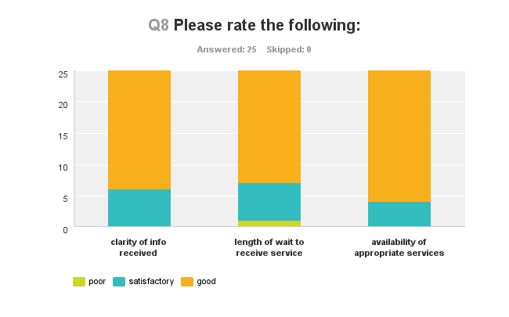
Clients praised KWHPC staff and FoF workers, with several commenting on the quick turnaround from referral to first appointment or group meeting. This can be crucial for clients:

“It was quite quick which I really needed as I was not in a very happy place AT ALL when I started. I had post-natal depression quite late. So everything turned out to be really good.”

One person made an observation about clarity of information for other clients who may be less clear about what might be useful for them:

“Personally I knew what I was looking for - tools to help me communicate with my son as he wasn't communicating, so the clarity of info was ok. If you didn't know what you needed I'd say the clarity of info would be poor.”

“There’s a lot of information available. Office staff are just lovely and very helpful. Vicki and Garth will try and find out answers to things and ask others instead of just saying "no, we don't know" and leaving it to me to find out.”
“There's lots of leaflets and information around.”

“They were good at the time.”

“It was quite quick starting, which was good.”

“I was quite pleased with initial response.”

“Length of wait - very good, no time at all. Availability of appropriate services - brilliant. Even the counsellor was lovely! Couldn't ask for anything better.”

Usefulness of FoF Services
100% (25) of clients thought the FoF services were helpful

“It was brilliant, exactly what I needed. 100% helpful. I was ready to ask for help and it was the right amount of help I needed at that time.”

Of the 11 comments made around this question, 4 reinforced that it was “all very helpful”, 1 mentioned the usefulness of the crèche nearby and also the value of the courses saying they “did what they were meant to do, it’s all good”

1 woman commented that (when she remembers) she still refers to her notes, to remind herself of tools and techniques to use: “Still got my notes from the courses about coping strategies. I still get them out when I'm having a difficulty and think "let's try that today". Sometimes it works, sometimes it doesn't.”

Another person thought the Womankind Counselling was “fab” but there was not enough of it available! She also reflected that for her, the Dealing with Depression group had been less successful for her as she felt the issues being discussed were not relevant to her:

“The Womankind Counselling was fab! There just wasn't enough of it! The Dealing with Depression course was fine in terms of the information given but the group was largely older men so a lot of the issues weren't relevant to me. The techniques offered were really helpful but as it was group therapy we spent a lot of time having conversations that weren't relevant and I couldn't relate to the older men.”

“It was helpful at the time but not really now. And then I was diagnosed with ADHD which explained why the medication I'd been on didn't work and previous counselling (Individual Counselling).”

Two clients made specific comments about the Play Therapy service, questioning the age appropriateness (or not) for toys and other resources for secondary age children:

“My son found the toys and tasks immature and not age appropriate, but it was useful because it gave me ideas for things I could do with him beyond the sessions which were age appropriate (Play Therapy).”

“I’ve got four children. Would say Yes it was useful for younger children. For secondary school children I would say No - it didn't fit so well, asking them to draw pictures. They didn't like that and got bored. It was a constant battle getting them to come. Little ones enjoyed it more than the teenagers. They wouldn't talk in the room but would talk about it afterwards. Family counselling was good. Play therapy - didn't relate to play therapy worker, didn't "click", didn't enjoy that.”

FoF Outcomes

NB. 21 responses were given for the FoF outcomes questions, 5 responses were given for the FoF+ outcomes questions, making a total of 26, 1 more than the 25 interviews collected. This is because in 1 instance a child referred by CAF also had another member in the household who gave views on FoF services they had used as well as reflecting on the child’s experiences of the services.

95% (19) of clients for whom it was relevant had a positive change in terms of their own Health and Wellbeing.

90% (18) of clients for whom it was relevant had a positive change in terms of their own family relationships.

95% (19) of clients for whom it was relevant had a positive change in terms of their ability to cope with day-to-day life.

69% (9) of clients for whom it was relevant had a positive change in terms of reduced social isolation (ie. getting out and meeting more people)

88% (15) of clients for whom it was relevant had a positive change in terms of reducing behavioural problems (ie. solving problems/dealing with things better).

No-one reported a negative change in any of the outcomes as a result of having used FoF services.

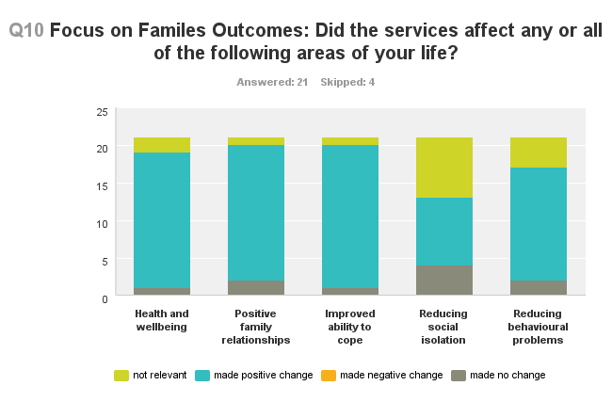
FoF+ Outcomes

If a client had indicated they were referred via CAF they were asked a slightly different set of outcomes questions, though some were the same as FoF, ie. health and wellbeing, and positive family relationships. The remaining FoF+ outcomes are more related to young people experiences including low levels of achievement, low levels of school attendance and behavioural issues. The sample is much smaller with 5 people’s experiences reflected in the findings.

For all FoF+ outcomes, a positive change was reported across the board, with only 1 instance of there being no change in terms of the client’s health and wellbeing.

No-one reported a negative change in any of the outcomes as a result of having used FoF+ services.

See the chart on the following page for FoF+ clients’ perceptions of how they are progressing and what outcomes they are achieving.

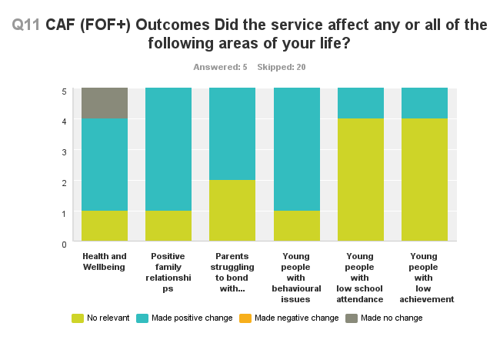
Comments from FoF and FoF+ users are jointly presented below.

“For my grandson the issue was anger management. He is much better now.”

"At the time it helped us deal with things better - I'd come home from the courses and we'd chat about things and ideas we might try out from the courses. It dwindles off as time goes by - things improved so there was less need to talk it through and then it slides and things get forgotten, before you know it you're doing the same old things and shouting. It's not that the tricks and tools are forgotten, they're just not top priority when other stuff is going on. Health and Wellbeing and Improved Ability to cope? Yes, it helped at the time but it's hard to sustain on your own. It’s easy to get back into old habits. I've still got my notes. A refresher course/top-up would be good, maybe a 1/2 day course to review and remind ourselves what we learnt.”

“I didn't make friends but do now chat and be sociable to another mum if I bump into her."

“It all feels so much better, everything is sorted now except for 1 person in my family. But everything else with everyone else is much better and I feel I can cope much better with life, and my anger.”

“The Making Changes group was useful as I was going through a difficult time. It helped me deal with things better (rather than solve problems). Then I had a bereavement so had some counselling with Ali. I did meet more people.”

“It helped a little bit to deal with family relationships but then my son got seriously ill and everything changed.”

“It's helped me deal with family problems better and improved my ability to cope a bit. I met more people and am still in contact with all of them, in fact I've helped some of them get out so good mutual support. It’s helped me deal with some things better, for example my anxiety, though it hasn't dealt with the children!
Positive on all counts! I've learnt lots of strategies to be able to cope better. I'd recommend it to anyone.”

“Making Changes has been especially helpful in helping me deal with the family better. I've made lots of friends at the Art Group and met lots of lovely people, this has really helped me feel less isolated. The Making Changes group is useful to dip back into again when you think you've got something licked and then it comes back and bites you on the bum. It’s really good to come back and do it again - try a different response to a situation, in a safe environment.”

“I believe it made positive changes, I got some good advice and had someone to talk to.”

“For the positive family relationships - what the counsellor was talking about made sense. The areas where it made no change, I can't blame the service for that - it was my ADHT (which was only just being diagnosed) and the medication I was on that wasn't working. I still have panic attacks and get really anxious but now I realise that's part of my ADHD.”

"My personal isolation still exists as I need to be there for my son and he doesn't cope well with social situations. I had to give up full time work to be there to support him.”

“It's helped us to deal with things better (rather than "solving problems")."

“It didn't really make much difference in terms of meeting more people as people were already all grouped together. I was hoping to meet people to go out for a drink with and chat about our issues but the people who already knew each other just stuck together so that didn't happen.”

“It made a (positive) difference at the time but we've now slid back. Daughter was 9 yrs old when she went. She liked going and having 1-1 play which was what she wanted.”

“Definitely positive changes for my daughter.”

“Helped me to think things through better.”

"It was a relief every week, to set a day a week to look at the issues and not try and sort it all out in my head all the time.”

“Meeting people and getting out more - Yes, but I still get frightened in larger groups. I come down every day now for a cup of tea in the cafe.”

"I'm gradually getting better but you know my dear I'm not in very good health - Garth did his best. I'm suffering from a broken heart you see, not easy to fix.
After counselling I joined the Art Club. Made lots of friends but after a while I was asked to leave, to make room for someone else. Now I go to a class at Philips Street and at the City Farm, that's very good. I was so proud - I got accepted into the Arts Academy. But I was mixing with 20 year olds and they would have walks to the galleries and I couldn't manage the walks (I'm 72 yrs old) so I had to give it up.
I was also in Fit and Fab Club, me and 2 other gentlemen and all the others were ladies. After a while we three men were chucked out. I'd like to know why we couldn't do it anymore, no-one explained to me why. I'd like to know why I was asked to leave both groups."

“It doesn't solve problems but helps you to deal with them better. Teaches you questioning skills, asking right questions about own situation and yourself. Helps me step back and take a moment before responding. I'm more self-aware."

“Counselling helps but also drains you emotionally, some weeks you just don't want to do it. It was hard. Daughter (now 26) was put off counselling. We never really worked out why she was so angry and she was taking it out on me. She was having problems with her boyfriend and wanted someone to blame - me! Not totally resolved everything.”

“Health and well being/feeling better - considerably better; dealing with family problems better - definitely; helping me cope more with day to day life - oh yes; solving problems and dealing with things better - yes definitely. It made me do things I didn't think I'd ever do (in a good way). It's the best thing I've ever done.
It helped me deal with things better - there's no magic wand to solve problems.
Helped me as a parent. Some positive tips, but sliding back. Was able to talk to them then but not now (the teenagers). Slipping back into old habits, this is a bag of s**t. Didn't think counsellor could relate to teenagers. Was ok with the little ones, but not with the teenagers.”

"Health and Wellbeing - yes, whilst doing the course. Improved ability to cope - no change, but that's down to me and my issues not the course. Reducing social isolation - no change, but it wasn't my motivation for doing the course."

“Made me recognise the help I needed and clarified a lot for me. It caught me before I got depression, tablets keep me out of depression now which is ok. I've made massive steps over the last year. “

KWHPC Customer relations

Although this question specified KWHPC, the responses demonstrate a seamless service delivery as comments refer to specific service deliverer from contracted agencies as well as KWHPC staff.

100% (25) clients were positive in describing how they were treated by KWHPC staff.

64% (16) said they were treated “excellently”, with a further 28% describing their treatment as “very good”/”good”. 8% (2) said it was
“satisfactory”.

This comment from one client encompassed what several other clients had voiced during their interviews.

“Whatever your scale (1-10) they're top of it! All the staff are very helpful and informative, and good at keeping you in the loop on things, eg. whether the new funding is in to run the group again. And if you stump them with a question, they'll go away and check it out and then come back to you. Sometimes I can't make it out of the door at home and they're very patient and understanding.”

Others, in explaining their positive response, shared a little more about how individual staff had supported clients, and how the service is having a positive impact.

“Its led into other things, so now I'm doing DBT (Dialectical Behaviour Therapy) - it's a bit like CBT, I'm learning about patterns of behaviours and how to change old ones so I don't always respond to things in the same old way. Chris Andrews was helpful writing me a referral letter.”

“Sue Jackson was excellent, so was Sally.”

“The play therapist was brilliant. She was the only one I had contact with.”

“They were brilliant”.

“They were friendly and helpful”.

“Everyone's friendly and nice. Everyone tries to help, I can't fault them”.

“They're all excellent there.”

“I'm much more appreciative of 1:1 counselling now. I would never have considered it before. But you have to be ready to ask for help. I would actually seek out counselling again in the future. There was lots of crying.”
“Overall the service is brilliant, and great that it was free.”

“Fantastic!”

The Best Thing about Clients’ Experiences of using the FoF project, and the Main Benefit to the Client having used FoF Services?

This question, and the follow up question about the Main Benefit to the Client of using FoF Services, have collectively elicited a wealth of stories which offer a snapshot into the diverse and complex range of issues that many are grappling with on a daily basis in Knowle West. Each story is of course unique, though some issues are recurring across even such a small sample. It is because of this that FoF was put in place, and the benefits to users are plain to see.

Both were open questions and all the responses as recorded are offered verbatim below.

Clients’ Experiences – best things experienced and the main benefits of FoF are paraphrased here, including:

- Getting out of the house/having a reason to get out of the house
- Realising I’m not the only dealing with these issues
- Being better able to cope with difficult situations
- Taking time to reflect before jumping in
- Making new friends, meeting new people, feeling less isolated
- Knowing I have someone I can turn to if I need them
- Having someone independent to talk to and share concerns with
- Feeling of being looked after by KWHPC staff
- Learning tools and techniques to deal with issues
- Learning and using new skills
- Getting on better with family
- Developing better communications with children/siblings/parents
- Growing my confidence
- Seeing my children/grandchildren managing better/blossoming
- Supporting my children better having been able to talk to someone external
- A bit of me time/down time (even if this was just waiting outside for child who was in Play Therapy)
- New baby on the way!
- Found new half-sister in India

Benefits also include:
- I’ve achieved what I wanted to do
- Its local, free and on the doorstep
- I know more about KWHP and what’s going on
- Feeling good about living in Knowle West. ☺
Comments are presented verbatim below. They have been loosely grouped into four themes of:

- Social capital
- Skills and knowledge
- Trust (of staff and other users)
- Wellbeing.

In reality many of the comments touch on several of these themes, highlighting the interconnectedness of these issues; that an improved sense of wellbeing and development of personal skills/knowledge to cope better with daily life, for example, can only happen when users have trust in KWHPC, the FoF team and the environment within which services are offered.

Verbatim comments:

Social Capital
“Got me out of the house in the daytime. I'd recently lost my husband and didn’t really like going out. Even now if I don't need to go out I won't. I have to push myself to go out to pay the bills. I got really nervous going to the courses, especially the first week, but it gave me something to aim for, getting me out. I was able to cope with certain situations. Good to have someone to encourage you on. I tried 3 times stopping smoking with Sally and didn’t manage it. I stopped going as I felt someone else should have that place. And last summer I managed to stop all by myself, and haven't started again until recently.”

“Having someone to listen to, realising I was not the only one going through this rubbish. Good to have a coffee and a chat too!”

“Contact with other people, meeting new people and growing my confidence.”

“Meeting friendly people. I didn't feel alone, I felt similar to them, facing similar problems.”

“Getting out and meeting people similar to myself.”

"I was getting out, meeting new people. Learning how to deal with new situations, and to cope better, for me and with my daughter, most of the time.”

“Getting out and meeting people having had a stroke. Learning new skills.”

Skills and Knowledge

“It gave me different ways of looking at things so I can work it out differently and not always respond in the same way when my buttons are pushed. It helps me see clearer and to step back before deciding how to react.”

“Being able to talk and get everything out. At the time it made me feel really good.
For me, it gave me ideas I still use now (3 years later) to get communication started. I need to think outside the box to get a conversation going, using other means. I can communicate with my son.”

“It brought my daughter (9 yrs old at time) out of herself. It gave her belief in herself and gave her more confidence. We could do with a top-up now and again, for example if she's struggling with her homework and starts doubting herself, and me!”

“Being able to talk to the kids at the time. Being able to take a step back and not get stuck into a situation without getting angry.”

“Fit and Fab was really good, it was about me which was what I needed. Family counselling was great for the family. I had split up from my husband, I made my daughter come to the sessions, my son would come sometimes if he wanted to but I couldn't make him. The Beauty Course was lovely and Laura was flexible about the 19yr old age rule and allowed my daughter to come. It was really great, the beauty course interested us both and gave us some good bonding time together. It was all so friendly and welcoming.”

“Learning what I've learned with Sally, and new skills (eg. bread making).”

“Showed my grandson (14 yrs old at the time) a way to show his anger without going off like a rocket! And he's sustained his progress. Imogen was calm and collected and he got on well with her. For me, it gave me another grown-up to talk to.”

"It was quick. Improved communication with this family. Being able to talk more, even if things are starting to slide back.”

“I think some personal counselling would be useful. I'd like help with controlling stress levels, would like to communicate with my teenagers, manage every life better - at the moment feels like being punched in the face every day of my life."

“KWHP - I've made lovely friends and come in every other day now for a cup of tea and a natter. I felt very isolated when I first moved here and didn't know anyone, I don't feel like that at all now."

“It reminded me of the management courses I had been on in the past, and reminded me of ways of dealing with managing myself and hope I deal with things. Good reminders!”
“The main reason I came to KWHP was because I had PND and day-to-day life at home and day-to-day life with the kids was getting me down. With the Parenting Course I found other ways to deal with the kids, new tools and strategies that I still use. With the Anger Management I learnt how to deal with me and feel differently about my day-to-day life. It gave me different perspectives on my life. It was hard at points but really helpful. It turned it all around for me and took me out of the box! And it gave me 5 new friends!”

“I've learnt different communication techniques so that I can communicate with my son, and I also try them in other situations, for example with my parents!”

“Finding out about myself. Before I had counselling (and I've had quite a bit now) I couldn't even go out of the door - was agoraphobic and everything. Couldn't even drive before, I can now.”

“Daughter is much more confident”.

“They both helped me understand my depression more and how I can make a change. I have achieved both.”

Trust

“Garth kept an eye on us, to see if the outcomes were good for the grandchildren, and then referred me to Ali. I had counselling over several months, it was very useful.”

“Everyone is just so friendly. Always a kind word or acknowledgement. Always got time to talk even if they're with an important person.”

“I'm not very good in a group, I'm better 1-1 but felt I got a lot of help from Ali and Chris in the group. And I got help in dealing with a difficult situation.”

"Having somebody independent I could talk to. It was someone to reassure me and put my mind at rest and someone to share my concerns about my daughter's welfare. It all happened so quickly. My daughter was taken away from her mother and I had to go and collect her from another part of the country overnight. I had to give up work to look after her - I'd worked all my life, worked away a lot and suddenly I was out of work and being a full-time dad. It was a huge change for both of us. It all changed overnight. Sometimes I felt cheesed off having to explain myself to a 20 yr old in the dole office, it's none of their business. Sometimes I wondered how I'd cope, you do your best don't you, that's all I can do. Now I'm working part-time. The counselling meant I had someone independent I could talk to in confidence, and get advice and share my worries with. As for my daughter, she’s had counselling too and I think it's helped her to cope and be more positive. Now her mother is trying to get her back and we're having to go to court again. It's not so good."

“Knowing that they are there and if I want/need to I can go in and ask for help.”

“Someone to talk to and pour my troubles out to.”

“Talking to someone that would listen.”

“I don't really know. I suppose being able to talk to someone as a friend.”

“Being able to talk somebody.”

“Talking to somebody completely unbiased - I've never done that before. It's started a process. I'm a lot more open, and talk to my sisters now too. We get on better (for the first time ever).”

“Introduced me to a lot of new stuff at KWHP. Not everyone knows your business - it’s confidential. Could pour myself out and not feel guilty about it (don't want to put on family and friends). Brilliant to have an objective observer/listener outside the family, although it would be nice to sort things out inside the family. I always want to be a fixer, and am thinking of volunteering or something, want to use that in a good way for people.”

“Something happened in my life that I needed to cope with. She (counsellor) enabled me to do that).”

“Able to talk to someone”

“I was able to talk about a problem and act on it. Talking to the counsellor and working things through. Because of it I found a half sister I didn't know I had. She's coming over next year, it's excellent. The counsellor, Rosie, was truly lovely.”

“I was only thinking this morning of KWHP and thinking I should come over to see what is on offer as I could do with some help at the moment. It is so good that you called this morning. It's given me the push I need to go and see what's going on. Maybe I'll try the stop-smoking again, and the weight loss, and some counselling - I really don't know what to do for the best at the moment with my daughter, who's depressed, she's had lots of bereavements and won't go to school or CAMHS. I don't know what to do."

“Realising I was not on my own.”

"Making Changes - I've felt more relaxed and relieved that I can talk about issues knowing it wouldn't go anywhere else. Ali and Chris are great. By the end of the day it (anger) was all gone and was all fine. It's a good way to get the niggles out, some I didn't even think were niggles.”

“Learning to deal with other people in a more appropriate way. Learning about myself and how to deal with others.”

“Advice, independent from family and in confidence. I could talk about stuff that concerned me about changes to my life and my concerns for my daughter's welfare.”

“It was very close so I didn't have to go far. They made you feel safe and welcome there.”

Wellbeing

“For my daughter? She got 1-1 play time, that's what she liked and wanted.”

“It was very helpful, people were very friendly”.

“Nice to be able to access services locally and it's great that KWHP offers such a range of services. Being there made me proud to be part of KWHP and to have it available. It made me feel good about living in Knowle West. It's such an important service - please say that! The Womankind counselling was brilliant but not enough (6 weeks) - just getting into things then.”

“Time on my own and letting everything come out. Got a lot of things off my mind and that made me feel better at the time”.

“For me it was the down-time outside the room whilst daughter was having 1-1. It was the only "me-time" I ever got/get.”

“More self-aware. More inclined to deal with problems instead of ignoring them.”

“Great that the tai chi classes are free. I did a bit of yoga but gave up. I'm not working and bills have gone up but benefits haven't so it's great that I can try the tai chi without having to pay and then when the free classes run out, if it's been of value to me, I'll make the effort at home to argue for continuing it.”

“Because of using the services it's had a really positive effect on my family. Definite improvements in the family, our wellbeing, my coping skills and how we communicate. My husband and I have got back together and are expecting a baby at Christmas!”

“I went to try to make me feel better about myself. And it did that”.

“It was a life changing experience to be honest. I was in a really dark place when I started coming to Knowle West HP. My life is so much better now (still lots to do but so much better!).”

FoF – Room for Improvement?

71% (17) of clients thought there was no room for improvement.

Clients were asked if there was anything that could have been improved. 14 responses were given. Of these, 2 comments were positive. 4 said there was no improvement needed with regard to their own experience and then suggested a need to raise the profile in the community. Of the suggestions made/issues raised these are the key messages:
Getting the word out more effectively about KWHPC and what’s on.

Ensuring resources for play therapy are age-appropriate, esp. for teenagers.

Offering top-ups and refresher courses to prevent progress from sliding back into old bad habits.

In addition to these, 1 person perceived the management team to be cliquey, the cafe aimed at vegan hippies, and too expensive. One person suggested that the time for Play Therapy be reviewed as her children were reluctant to come if it meant missing school after-school activities.

“Not for us, but generally I think it's not very well advertised. People in schools are not well aware of it. I've told mums on the playground and taken them down there.”

“For me, No. Perhaps letting people know a little more about what's on offer at KWHP, making more people aware.”

“No, everything seems to be really well set up.”

“All really good.”

"For our own experience, more age appropriate toys/tasks. For everyone else, letting people know what KWHP are doing. If I'm honest it really cliquey - if you're not in with the management team you don't really find out what's going on. All this money's spent on a glossy magazine and most people don't really give it a second look. They've got this really great cafe at the moment, but it’s only the hippy type people that use it. I know they're trying to offer healthy food but it seems like they're catering for the vegan hippies all the time, and prices are way too expensive. I do go there once a week with my son for tea and cake, it's our protected time and we have a chat. It's really valuable as I have two children so this is one of the ways I've created to be able to talk with my son. “

“They need to be keeping their profile up all the time. I live quite nearby so I can find out if I need to but word of mouth is the main way and they're not getting it across to the people who need to know."

"Psychodrama - I found this quite distressing, role playing my situations. It was too personal for me. My husband would pick me up each week and say ""you look more depressed than when I dropped you off"", which I was. So I packed it in. I think you need to explain in more detail that's what the group is about. I didn't realise it would be my situation that would be acted out. “

“I completed and enjoyed the Heath Matters, Worry Management and Anxiety courses and enjoyed them all. I think the Health Matters should be more detailed. You give us this big folder but then not much to put in it! I want more detail on each topic and handouts. More time to discuss each topic.”

“Meeting in the evening was difficult for me and I'd prefer to meet in the day but I realise some people work so that won't work for them."

“It would be good to have a top-up available. Or someone to call when I have a question (having previously had counselling for father and daughter).”

“It's probably down to funding but 6 week courses don't really do it. Need some longer term support like the Arts Classes. Maybe at Philips Street it is longer term support.”

“Shorter waiting time to start the counselling would make it better.”

"longer terms services available. Maybe taster sessions with different counsellors to see who you get on with, then choose your counsellor.”

“Brilliant Walk-in Centre but shame services are being cut. I have to go over to Barton Hill (Wellspring) for treatments now (eg. deep tissue massage, good for my bad back). Some practitioners there are interested in running services at KWHP."

"Times of sessions were stupid. Came on bus with children so they kept missing extended learning (ie. football) at school so they didn’t want to come.
Are the counsellors trained in working with teenagers AND young children? Need someone that can relate to both age groups, especially teenagers.”

“Not sure how to say this without sounding bad but it was sometimes difficult in the sessions because the kids would mumble and the counsellor, who had hearing aids, didn't hear and had to keep asking them to say it again, and I'd be telling them to speak up and it was all a bit difficult."

“More Women's Counselling.”

“Not for me at that point in time. You have to be in a certain mindset to ask for help and to open it up, it's tricky. Can you advertise it more, have taster sessions, people can share their positive experiences. Let people know it's there all the time. So that when they do get to the point they want to ask for help, they know where to get it from.”

Worker referrals of clients into other services

64% (14) of clients who answered the question had other services suggested to them by FoF workers.

2 respondents could not remember any referring on to other services. Some FoF staff were identified as being proactive in sharing information about, and encouraging take-up of, other services, notably Sue, Sally and Chris. Some suggestions of follow up services were followed through, others were declined or could not be taken up, due to on personal preferences and circumstances

“Sally and Sue were great - "there's this course coming up..." and then I'd put my name on the list.”

“Sally suggested the Art Class and other courses that I might like to do.”

“Chris Andrews suggested the DBT and wrote a support letter for the new course.”

“Suggested something up at the Park but I don't like it up there. And anyway, this is very handy as I only live round the corner.

“I went back to Ali for counselling after a bereavement - it was very useful and helpful.”

"Yes, but because my son got seriously ill I couldn't get to the extended course. My son is with me 24/7. He's gone from being a confident "out there" 13 yr old to an angry, unconfident boy. It's really hard. He's under the Registered Disabled Team but I don't really know what support is available for him, or for me. He's just starting on a "moving on" programme so now I get 3 hours on a Weds morning for me. (Evaluators comment: we talked about the free tai chi sessions and I gave her KWHP's phone number - she said she would call to chat to see what was available, to support her, and her son)."

“There were sheets available of upcoming courses linked to what I was doing. Some were relevant, others were not what I was looking for.”
“Not sure. Was given some leaflets.”

“Information was around but no specific suggestions/referrals.”

“Very good at telling me about other services, at KWHP and elsewhere.”

“He offered for me to talk to someone else about some issues that came up.
Group counselling for women in distress. I declined. I want to be in a place to share positive experiences, not dwell on the negative stuff (don't mean to sound bad or dismissing others' problems). But that's just me and where I am now. I would do individual counselling again if I needed to.”

“Can't remember.”

“Via CAF, did the Mothers and Daughters course at Filwood. And a Beauty course at Knowle West.”

“Sue was brilliant. She gave me lots of leaflets and she rings from time to time to let me know what's going on. It really helps a lot.”

Recommending FoF to Family and Friends
100% (25) of clients said they would recommend FoF to family and friends

4 said that they already had recommended it, with one person commenting “I do it all the time!” 1 respondent said she definitely would, reflecting on the difference it had made for her daughter who had blossomed after counselling through FoF, but also reflecting on her own feelings about asking for help.
And a bunch of flowers is due for Sally, whom 1 client describes as “marvellous”.

“Yes, I have recommended it to friends.”

“Yes, to everyone!”

“Yes I already have! And I don't usually answer the phone so I'm glad I did!”

“Definitely. It was so helpful for her. I didn't know how to help her. I'm glad I asked for help but felt I'd let her down by not being able to help her enough on my own. I'm glad I did otherwise she wouldn't be where she is today.”

"I would recommend it but not many people with same problems as me. Mental health is a big thing.”

“Yes, to a family member. Don't know if she'd come or if service available to people in Whitchurch. Lots of issues.”

“Really impressed that this is available in St Anne's and not just in Knowle and Filwood. You need to advertise it more otherwise people don't know what is available. I always give you a plug and promote you at coffee mornings I go to as I know that there's more people who could do with using your services.”

“Sally is marvellous, Give her a bunch a flowers, she deserves it!”

“I do it all the time!”

Conclusions/recommendations

Although a limited sample, the feedback from stakeholders, in particular from Clients, illustrates a model of service delivery which is working well and enabling clients to achieve a range of positive outcomes for themselves, also impacting favourably on their immediate families.

Solid and productive partnership working has been developed throughout the life of the project and communications between KWHPC and its delivery partners and referral agencies is overall perceived as positive and productive.

There is always room for improvement and with the continuation funding for FoF in place, there is opportunity for KWHPC to take the findings from this evaluation and explore a number of issues to take forward. These might include:

From Clients’ feedback:
- Widening Reach – raising the profile of FoF services, develop email lists, posters in shops etc.
- Widening scope of services – geographical reach
- Establishing a Follow-up Check- check 6 months/year later after initial service take-up to prevent people “sliding back”
- Developing refresher courses and “top-ups” (from short courses and counselling techniques for example)
- Maintaining and further developing a pick and mix menu of services allows choice and flexibility
- Develop more programs with local schools to raise awareness of services through school communities.
From Workers’ feedback:
- Cross referencing, do workers know full suite of services available? Are all workers open to referring to other FoF services?
- Monitoring – systems now rigorous unlikely to change
- Peer supervision meetings or other opportunities to exchange work progress
From Managers’ feedback:
- KWHPC, clear leadership, culture and environment for staff and users
- Services are greatly appreciated, accessible, professional, free, on the doorstep
- Positive outcomes are being achieved by clients.

In talking with users, the complexity and intensity of the issues many are facing is sometimes overwhelming and usually without a “quick-fix”. The need for FoF services continues, the value of it is seen from all stakeholder groups represented in this report. None more than users’ for whom it can literally be life-changing:

“It was a life changing experience to be honest. I was in a really dark place when I started coming to Knowle West HP. My life is so much better now.”

VINESWORKS, November 2013.
Appendices

Appendix 1. List of organisations consulted as part of the FoF evaluation.

Holders/Managers of FoF Service Level Agreements. 8 were consulted, including;
- Ali Simmons (Psychodrama)
- Barnardos
- Butterfly (Play Therapy)
- Chris Andrews (Psychodrama)
- GAN West (Men’s Counselling)
- Sue Jackson Associates (Psychosocial Workshops)
- Womankind (Women’s Counselling)

FoF staff/workers - those people who actually deliver the contracted services. 12 were consulted, including:
- Counsellor
- Women counsellors
- Parenting counsellors
- Family therapists
- Psychoeducational Groupwork staff
- CAF counsellors
- Making Changes group leaders

Partners/Referrers of clients into FoF services. 25 were consulted including:
- Health Visitors at William Budd
- Children’s Worker, Knowle West Early Years Centre, Children's worker
- Social Workers, Children and Young People’s Service
- Social Workers, South Bristol Early Intervention
- GPs at Crest Family Practice
- GPs at Merrywood Practice
- South Bristol CAF Team
- Engaging Families Worker
- Probation Officers, Avon and Somerset Probation Trust
- School and Family Link Worker, Ilminster Avenue Primary School
- Community in Partnership
- Positive Minds Manager
- Pathways to Health Coordinator
- Health Matters/Healthy Lifestyles Coordinator
- NHS Health Trainer

Appendix 2. Follow-up progress from previous evaluation

Knowle West Health Park Company - Focus on Families

Responses to recommendations from the Evaluation of the Project 2011

Recommendation 1:
There needs to be some more work on the identity of the programme. Partner organisations need to be sure that they are letting clients know that they are on the Focus on Families programme. Most clients were unaware of the name Focus on Families.

We have continued to market services using a range of media; brochures, posters, flyers, websites, and by supplying referrers with information packs. The numbers of referrals including self referrals continue to exceed expectations, suggesting that information about the availability of the project is sufficient, even if there is some confusion about the exact name of the project. Service users know who they see and what for, e.g. group or one to one work, but not necessarily that there are several different types of one to one work or group. This does not pose significant problems as long as service user needs are met, which the report suggests they are.

Recommendation 2:
Consideration could be given to providing a questionnaire to each client at the end of their time with FoF to be completed. Given that people may struggle with reading and writing, a verbal questionnaire could be completed with each client. Whilst it is realised that this would be more work for each project provider, it is worth thinking about costing this into new contracts.

The project seriously considers the need to obtain honest feedback from service users that can be evidenced (anonymously), against the low literacy levels that exist within sectors of this community. It also weighs up the costs of direct service delivery versus administrative tasks. For this reason, it has decided to use end-of-service questionnaires with plain English and quantitative feedback methods, such as ‘tick boxes’, as the simplest and most cost effective means to get feedback from service users. Service users also have the option to ask workers to explain the feedback forms, or can take them away to ask a friend/family member to assist them with its completion. Finally, a substantial budget is set aside to commission an external evaluation, which relies primarily on gaining verbal feedback from service users.

Recommendation 3:
An initial meeting of all new providers working with KWHPC to attend a meeting prior to starting the project. This would reduce the initial confusion experienced by many new providers at the start of the project.

Each provider has several meetings individually and with other providers prior to starting the work, mainly to work through and agree the terms of their Service Level Agreements. Each worker for that provider also meets with the Co-ordinator to discuss the work and the Administrator for a practical induction into working in the building.

Recommendation 4:
As the cross referring seemed a little low it would be good practice to be sure that all providers are aware of what other services are available within the FoF project, to promote better cross referring.

Providers meet other providers through two regular meetings, for front line staff this happens in the peer group meeting and for managers there are regular managers meetings. Front line staff have been encouraged to refer to other services at Peer Group meetings, the extent to which they do so relies on their motivation and willingness. This will be closely monitored going forward, and will be written in to the next set of SLAs. The current evaluation will also ask each worker about whether they have made cross referrals.

Recommendation 5:
Background information about the area to each provider would be useful, whilst some organisations are very aware of the needs in Knowle West, some individual providers would benefit from some additional information.

New partner organisations are selected for their knowledge of or track record of successful delivery in the area.

Recommendation 6:
It may be worth pursuing the scope in any new funding bids to look at Tier 3 as this was bought up by a few of the providers.

Generally there has been a move away from the Tiered model of treatment, which may be helpful in terms of people getting their needs met by city wide mental health services. However the priority for this project is to keep offering family orientated interventions (not available in generic mental health services) and to work within the scope for managing complexity negotiated between KWHPC, partners and staff, to ensure we undertake our duty of care and provide excellent standards of service delivery to service users and others.

Recommendation 7:
An assessment process would add great benefit to this project, particularly for those providers that get a high number of referrals. It may be worth looking at funds to employ an assessor to see clients and ensure they are suitable for the provider they are referred to.

Service user feedback from local, regional and national projects shows that being repeatedly assessed is a great concern to people using services. Assessment is a big part of building rapport in the therapeutic relationship and KWHPC does not see value in having someone who is unlikely to work with the person asking them to share details of their life. It is likely that even if a separate assessment stage was implemented, individual workers would then do an assessment for themselves, to help them understand why the person requires services. KWHPC has instead put in referral and screening processes which identify key issues and allow us to match need with the skills and expertise of different services/ workers.

Recommendation 8:
A weekly/fortnightly session with the project coordinator would benefit some of the providers. A telephone appointment would make sure each provider is up to date on a regular basis.

This happens informally with workers who need the support, because they tend to use the Co-ordinator more than those who do not. This is also an issue for staff who are “freelance” or working independent of an employing agency, more than it is for those who work for a contracted organisation, and get line management support from that organisation.

Recommendation 9:
Services need to be extended or made more flexible to be able to provide services for longer or enable the providers to extend the services on an individual basis. Some additional outreach support would assist with this issue.

Each case is judged on individual merit and where clear needs arise we do sanction extending the intervention. Workers also research and attempt to facilitate the onward referral of clients to additional services, wherever possible, which are appropriate to the client’s needs once they have completed their contact with this project.

Knowle West Health Park Company
5 Knowle West Health Park
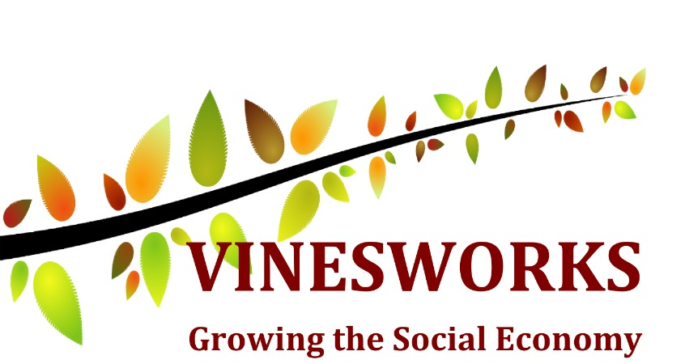
Downton Road
Bristol, BS4 1WH

0117 377 2253 / www.knowlewesthealthpark.co.uk
Company No 5879576 / Charity No 1137797

