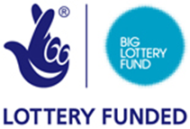



**The Art-Ease Project**

Evaluation and Social Return on Investment Analysis of an arts and mental health project delivered by **Knowle West Health Park Company**, Bristol

**Summary Report**

**Key Points**

* The aim of this research was to evaluate the impact of the Big Lottery funded Wellbeing project on its participants. The research also sought to assess the wider social value that the project is creating using a Social Return on Investment (SROI) analysis.
* Knowle West Health Park Company’s Art-Ease Project is aimed at improving the mental health and wellbeing of people with mental health needs in the Knowle West area of south Bristol. The project offers group-based arts and craft activities along with 1-1 counselling support.
* Social Return on Investment (SROI) is a framework for measuring and accounting for change in ways that are relevant to the people or organisations that experience or contribute to it. It seeks to capture social, environmental and economic outcomes and uses monetary values to represent them.
* Mental wellbeing is a fundamental component of good health. Mental illness is hugely costly to the individual and to society, and lack of mental wellbeing underpins many physical diseases, unhealthy lifestyles and social inequalities in health.
* The evaluation includes data from 89 people who took part in group based sessions during the first 19 months of the project; 31 of whom also took part in 1-1 counselling support.

**Key Findings**

* The majority of people self-refer to the project, often with recommendations from partner agencies. Baseline assessment shows that up to 45% of participants have complex and severe mental health needs and social difficulties.
* The evaluation found strong personal testimony from interviewees, and detailed evidence for a sub-set of 31 out of 89 participants, of the benefits of Art-Ease Project. After 3-4 months participants using before-and-after validated questionnaires 7 out of 10 participants (N=31) showed reduced symptoms of moderate to severe depression, and/or anxiety and improved wellbeing scores.
* Participant self-reports and project records provided evidence of wider positive impacts on addressing trauma, distress and other debilitating social circumstances. One in two participants reported fewer GP visits and an estimate of 6 people avoided crisis support from NHS mental health services in the evaluation period.
* Participants and agency partners attribute the benefits of the Art-Ease Project to the friendly fun and creative groups; the feeling of safety and the option to obtain 1-1 counselling support alongside the group activities.
* SROI analysis identified a significant social return for the investment made; for every £1 spent on the Art-Ease Project there is £3.31 of social value created.

**The Art-Ease Project**

**at Knowle West Health Park**

The Art-Ease Project is aimed at improving the mental health, wellbeing and resilience of people with mental health needs of people in Knowle West and the surrounding area of South Bristol.

Knowle West Health Park Company (KWHPC) run two Art-Ease groups every week that operate out of the designated art-room at the health park. These groups run for twelve weeks. The groups are facilitated by a professional artist who is also supported by a volunteer and a trained wellbeing counsellor who offers individual counselling for group members. In addition two ‘independent’ art groups also offer participants a lower intensity of support from the artist and wellbeing counsellor.

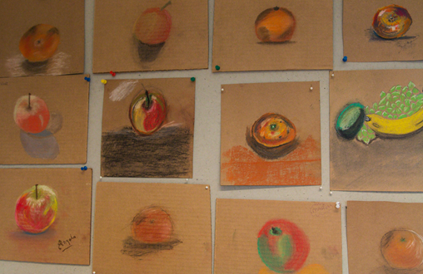

KWHPC is a charitable company limited by guarantee; the Board of Directors is primarily made up of local residents of south Bristol and has representatives from local partner groups including Bristol City Council. KWHPC is located on the Knowle West Health Park, originally a joint initiative between the local community, Bristol City Council and NHS Bristol. The Health Park was developed in response to evidence of poor health in the Filwood electoral ward. KWHPC aims to provide high quality services to improve wellbeing, prevent illness, promote good health and assist recovery after medical treatment.

Art-Ease is one of a broad range of projects provided by the KWHPC. The organisation also focuses on key areas of health improvement relevant to local people, for example prevention of coronary heart disease and diabetes, obesity, smoking cessation and mental health problems. The strategic imperative of the company is to help people help themselves, building independence through increasing levels of confidence and motivation.

Previous research of the KWHPC and partner organisations’ services[1] identified positive changes in mental health, personal and social well-being for participants. The current evaluation sought to build upon this evidence, and to examine the wider social and economic value of a leading KWHPC project.

**Importance of mental health & wellbeing**

Mental wellbeing is a fundamental component of good health. Mental illness is hugely costly to the individual and to society, and lack of mental wellbeing underpins many physical diseases, unhealthy lifestyles and social inequalities in health[2].

It is estimated that mental health problems impose a total economic and social cost of over £105bn a year[3]. The economy loses more than £30bn a year from sickness absence and unemployment caused by mental ill health, while treating mental health problems cost the NHS and social care over £21bn a year. But the majority of the financial burden of mental illness falls on patients and their families, with the impact on quality of life costing £53.6bn.

**Access to mental health support**

Despite a wealth of published evidence about effective interventions to promote mental wellbeing and prevent and treat mental illness both anxiety and depression often go undiagnosed and many individuals do not seek treatment. Certain groups are known to have particular difficulty in accessing mental health services, especially those in low income groups and those with other health and social problems. This is relevant to Filwood ward Bristol which in the 10% most deprived areas in England. There is good evidence that interventions that seek to improve wellbeing at individual and community levels can help to increase resilience to the wider impacts of the social determinants of health and risky behaviours. Changes may also impact on health and social care service use, limiting dependence on more costly intensive services. Supporting social engagement and reducing social isolation also provides benefits to the wider community by enabling a possible ‘harnessing’ of potential contribution to the community through, for example volunteering and caring responsibilities11.

**Research aim and methods**

This research is part of a wider University of the West of England (UWE)-led study of projects funded by the Big Lottery under the South West Well-being Programme. This study aimed to evaluate the impact of the project on participants and assess the Social Return on Investment (SROI) generated by the KWHPC’s Art-Ease Project. In addition we used the RE-AIM framework to review the learning from evaluation.

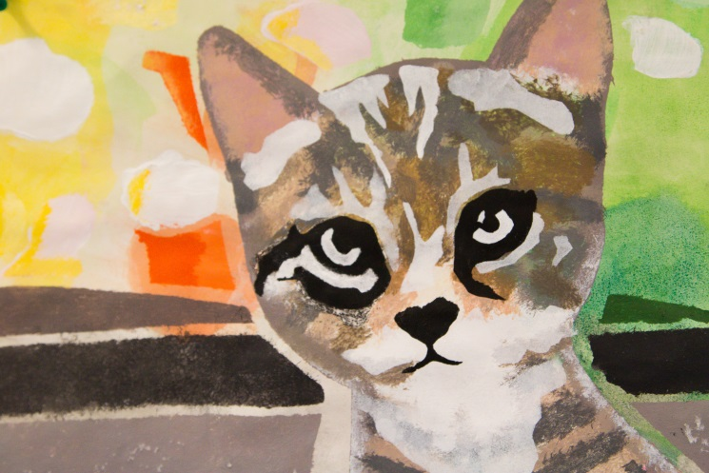

The analysis focuses on a 19 month period between July 2013 and January 2015 in which KWHPC received a grant for the project from the Big Lottery Fund, with additional match funding from various sources. Following the SROI methodology we adopted a mixed methods approach to triangulate stakeholder interview data, participant questionnaire data and practitioner records. The evaluation team conducted semi-structured interviews with 9 project participants, 6 members of staff and management from the project and partner agencies, and 2 volunteers.

Participants completed forms for registration, personal goals and service feedback. An in-house questionnaire designed covered perceived changes in general health, mental health and wellbeing. This was used alongside the short Warwick-Edinburgh Mental-Wellbeing Scale (SWEMWBS). The questionnaires were designed for use at enrolment and at 12 weeks or the final group session.

**What is Social Return on Investment?**

SROI is a framework for measuring and accounting for change in ways that are relevant to the people or organisations that experience or contribute to it. It seeks to measure social, environmental and economic outcomes and uses monetary values to represent them. SROI captures wider forms of value often left out of more traditional methods of economic evaluation such as cost benefit analysis.

Interest in social value has been raised by [The Public Services (Social Value) Act](http://www.legislation.gov.uk/ukpga/2012/3/enacted) (2013). The Act requires public bodies to consider how the services they commission and procure might improve the economic, social and environmental well-being of the area.

The act defines social value as *“the benefit to the community from a commissioning/ procurement process over and above the direct purchasing of goods, services and outcomes”.*

The wellbeing counsellor recorded mental-ill health issues (such as anxiety and depression) as well as social issues (such as experience of domestic violence). A ten-point scale was used to assess the severity of the issue at the points of first and last contact. At the point of last contact the counsellor also logged a written summary of observed changes. All practitioner and participant data were anonymised before the point of analysis by the evaluation team.

**Project participants**

In the evaluation period of 19 months, 89 people registered and took part in a number of Art-Ease Project group sessions.

Of these 89 individuals, 31 took part in 1-1 counselling sessions. KWHPC recorded a 190 people who were indirect beneficiaries: that is family members or friends of the 89 registered participants who might indirectly experience benefits from the project. An additional 27 people attended one-off events and taster sessions linked to the project.

Although the majority of participants are self-referrals, these are often made through of other organisations, including statutory mental health services, GP surgeries and activities at KWHPC.

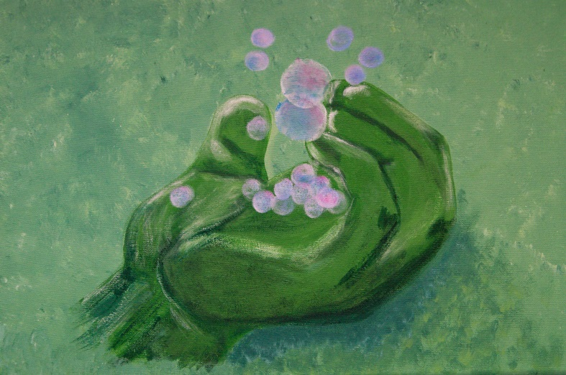

Eighty nine per cent of participants were female and 88% self-identified as white British, with less than 5% self-identifying as non-white. 80% of participants were over 40 with 26% being over 55 years old and 24% being over 65. 15 out of the 42 participants who opted to disclose, were disabled (36%). Only 17% were economically active or returning to work with 30% having retired and 37% receiving unemployment or long-term sickness / disability allowance. 36% were responsible for looking after children or caring for another person.

**Mental health and social issues addressed by the Art-Ease Project**

Project records of 31 individuals in contact with the wellbeing counsellor showed high levels of mental health and social needs. All 31 individuals experienced moderate to severe anxiety and/or depression; 42% (n=13) had current or recent history of sexual abuse; 26% (n=8) had a current or recent history of domestic violence; 64% (n=20) experienced psychosis, bipolar disorder, post-traumatic stress disorder, agoraphobia, obsessive compulsive disorder, and/or drug and alcohol problems.

It is important to note that 45% (n=14) had circumstances – in the majority of cases more than 2 circumstances- that were rated as ‘severe’ (8-10) by the counsellor.

In keeping with the ethos of the project, Art-Ease practitioners did not ask participants who only took part in group activities to disclose information about difficult and sensitive issues. However the experience of the project team was that mental health and social circumstances of group participants were often similar to those who took part in 1-1 counselling.

#### 

**Outcomes reported for the project**

The following sections summarise the main outcomes identified by stakeholders and outlines available evidence of their impact.

#### Reduced depression and anxiety

A strong theme emerging from both the interview and project records was that participants reported a more positive outlook and reduced levels of anxiety and depression. The wellbeing counsellor exit assessment with participants recorded reduced anxiety and depression scores for 22 out of 31 participants (71%). In interviews, participants talked about having more energy, feeling more positive and feeling less anxious. These responses are backed up by the outcome data collected from the mental wellbeing questionnaire measures, which recorded an average change of 7 in response to the statements ‘I feel more positive about myself’ and ‘I’ve been feeling more cheerful’ whereby 1 signifies no change and 10 signifies a massive change. 18 of the 30 participants who completed this form scored 7 or above in response to the statement ‘I feel more positive about myself’ with 17 of the 31 participants scoring 7 or above in response to the statement ‘I feel more cheerful.’

***“I used to have to come in and sit by the door, leave the door open, the main door I had to have it open because of my anxiety, now I’m safe in there now… I get panic attacks anyway, so even going out my front door to go to the shops was a big deal, but having to come here too many doors, corridors I was scared but it made me feel safe here.”* Participant W**

**Increased confidence**

All of the participants interviewed stated that they had experienced an increase in their confidence as a result of attending the Art-Ease activities. Participants stated that they gained confidence in a variety of ways but particularly through learning and mastering skills and techniques that previously they had thought themselves incapable of performing and through exhibiting their work and receiving positive feedback from staff, other participants and members of the public. Increased confidence was also seen as the cornerstone for making and sustaining other positive changes such as being able to leave the house more and undertaking more exercise.

***“I’m a heck of a lot more confident. I know it sounds a bit dramatic but coming up here… has given me my life back.”* Participant S**

**Increased levels of self-worth**

Another significant area of value creation for participants was with regards to an increased sense of self-worth, purpose and fulfillment. Participants talked about how the project gave them something to look forward to each week and how in having something to show for their efforts - and to share with friends and family members – the Art activities gave them a renewed sense of self-worth. Participants talked about continuing art activities outside of the Art-classes and the way in which these activities left them feeling stimulated and inspired.

***“It’s made me a proper person again basically. Even my family, even they have noticed a difference in me. They say you are a completely different person, you have gone back to who you used to be, but you’re worse, you’re much cheekier than you used to be!”* Participant S**

**Less dependence on statutory mental health services**

The support provided by the staff and other participants of the Art-Ease programme, creates increased resilience for participants, meaning that they do not have to re-engage in statutory mental health services during periods of personal crisis. This results in the NHS experiencing a lower demand for its statutory mental health services, freeing up capacity. Of the nine participants interviewed, one specifically stated that they had avoided relapse and a return to mental health services as a result of their engagement with the Art-ease programme.

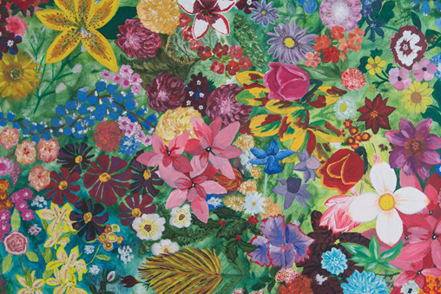

Given that 1 of the 9 participants interviewed talked explicitly about how accessing the Art-Ease service had allowed them to avoid a breakdown and return to inpatient mental health services it was considered appropriate to estimate that in total 6 of the 64 participants who had engaged with the Art-Ease group more than five times would experience a similar outcome, although this could be significantly higher given that the stigma around mental health, and the challenges of talking about one’s own mental health might have prevented other interviewees from talking so explicitly about their own mental health experiences and the likelihood of relapse.

***“I could have had another major break down as far as I am concerned, in-fact everybody was waiting on it to be honest, if anything was going to give me the push to have another relapse, you know, so.. It’s impossible to measure what situation I would have been in if I didn’t have this.”* Participant T**

**Less dependence on GP Services**

Participants also stated that in increasing their resilience, attendance of the Art-Ease activities also reduced how frequently they had to attend their GPs for support with their mental health needs. These claims are supported by the outcome monitoring data collected by KWHPC. Of the 31 participants who responded to the statement ‘I have visited my GP less often’ the average score was 6 out of ten (where 0 = ‘no change’ and 10 = ‘massive change’) with 16 of 31 respondents scoring 7 or higher.

**“I have been to my doctor less since I’ve been here than I did before. I didn’t know what was going on, I was so fed up with myself and indoors, I would just (…) up there. Now I don’t need to because I’ve got something else instead, you know, take my mind off things. I don’t have to sit at home and think oh I’ve got pain, what’s this, is all that coming back again.” Participant S**

**Additional reported outcomes**

The wellbeing counsellor’s descriptive data for 31/89 participants and interviews identified a wide range of additional changes:

* 13/31 people were better able to manage trauma, distress or other forms of difficulty associated domestic violence and/or sexual abuse.
* 5 people reporting less alcohol or drug problems.
* 3 interviewees who reported improved physical activity and healthier eating.

**Social Return on Investment Analysis**

The SROI analysis involves a stage-based process that involves mapping outcomes from the perspective of stakeholders; defining the relationship between inputs, outputs and outcomes; evidencing outcomes and giving them a value; identifying those aspects of change that would have happened anyway or are a result of other factors to ensure that they are taken out of the analysis; and then calculating the SROI.

***Inputs***

The annual Big Lottery Fund budget over for the Art-Ease Project was £35,586. This includes funding for a sessional Art Group Worker, a mental health counsellor, KWHP support staff, general overheads, running costs and additional expenses associated with delivering sessions.

***Outputs – Delivering the Project***

Over the evaluation period, Art-Ease group activities were largely delivered to the planned 12 week rotation format. The ‘indie’ spin-off art group had a more informal structure that reflected its delivery as a largely self-directed group.

Excluding those who only attended one session, clients attended an average of 8 1-1 wellbeing counselling appointments (min3:max15) held at a minimum of weekly intervals.

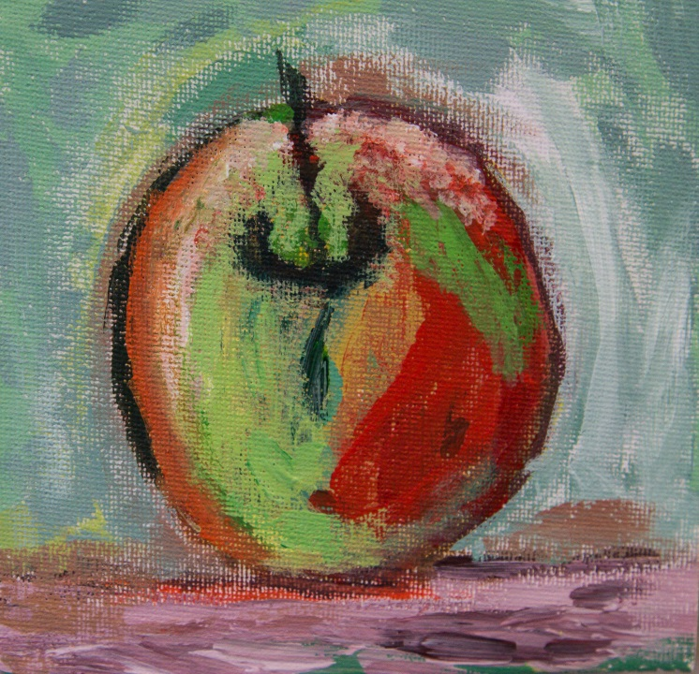

***Valuing outcomes***

In SROI we use financial proxies to estimate the social value of non-traded goods to different stakeholders. By estimating this value through the use of financial proxies, and combining these valuations, we arrive at an estimate of the total social value created by an intervention. The table at the end of this report provides a summary of all the outcomes included in the SROI analysis and how they were valued.

**Calculating the social value**

SROI analysis found that the SROI ratio is 1:3.31. This means that the SROI analysis estimates that for every £1 spent on Art-Ease Project there is over £3 of social value created.

The total present value for the 89 participants who took part in 19 months of the Art-Ease Project calculated from this analysis is £202,952. Whilst project participants are the greatest beneficiaries of Project (71%) there is also substantial benefit to local GP NHS services and NHS mental health services (26%), as well as to KWHPC, the Local Authority and partner agencies (3%).

**Strengths and limitations of the research**

The evaluation and SROI built upon a good set of quantitative baseline and follow-up assessment records made by the wellbeing counsellor. The assessments consisted of numerical ratings applied by a qualified mental health practitioner. Additional questionnaire data collected for the group based activities supplemented this information particularly with regard to wellbeing and positive outcomes. For good reasons sensitive personal problems were not assessed in group contexts.

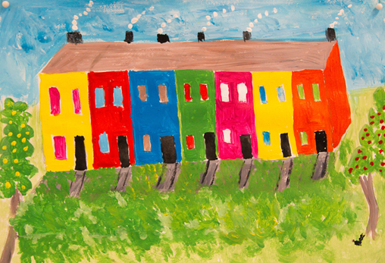

Within the timescale and resources it was not possible to collect data for longer-term outcomes beyond 4-6 months from enrolment. Some benefits important to stakeholders have not been monetised. It was beyond the scope of the study to fully explore the costs and benefits of the combined role multiple KWHPC activities available to participants. Similarly we did not assess the value of the project for the estimated 190 indirect beneficiaries (friends and family members).

**Conclusion and recommendations**

The Art-Ease Project at KWHPC delivers a service to adults in south Bristol who have high – and often severe – levels of mental health and social needs. The SROI analysis has demonstrated that the Art-Ease Project at KWHPC has been effective in bringing about substantial positive changes for people who have used the service. Overall the Art-Ease Project at KWHPC has created a social value of over £3 for every pound of investment. This figure is based on research involving 1-1 interviews with members of staff, participants and external stakeholders and the use of quantitative data.

Of particular interest is the role of the Art-Ease Project in helping people to address social and personal trauma, crises and ongoing difficulties. The project offers a safe, informal and friendly environment. The focus on wellbeing, creativity and fun is perceived to be a refreshing alternative to the illness -orientation of medically-led services. The option of counselling provides a space outside the art group to deal with personal and sensitive issues. Overall, the role of the project in helping participants to withstand or become more resilient towards adversity has positive implications for other parties. Whilst non-events are inherently difficult to demonstrate, perceptions that participation in projects like Art-Ease helps some avoid GP and mental health services need to be factored into the design and commissioning community-led mental health services.

**The Art-Ease Project Model at KWHPC**

**Wellbeing Counselling**

**Self & Partner Agency Referral**

**Confidential**

**Tailored therapeutic approach**

**Appointments flexible to need**

**Group Activities**

**Arts and Creativity**

**Safe & supported by trained staff**

**Peer support**

**Community volunteering**

**What is the RE-AIM Framework?**

RE-AIM is a useful framework for reviewing community projects that have public health goals.

**Reach**

Does the intervention reach the target population?

**Effectiveness**

Does the intervention achieve the assumed goals, without negative outcomes?

**Adoption**

Was the intervention broadly adopted at the community level?

**Implementation**

Was the intervention consistently implemented at a reasonable cost?

**Maintenance**

Does the intervention have the ability to be sustained, with long-lasting effects?

Using the Re-AIM review framework[4] we can summarise some key areas of learning from the evaluation:

* **Reach.** The project clearly reaches adults with moderate to severe mental ill health and social needs in the target area.

Careful application of eligibility criteria means that the project is taken up by people with high social needs. This means the project is well placed to address inequalities in health.

* **Effectiveness**. There is practitioner assessed evidence of short-term impacts, supplemented with self-report pre-post questionnaire data. There are individual reports of longer term and wide ranging personal and social effects. No significant negative outcomes to participants or partner agencies were identified. SROI analysis helps communicate the project’s social value.
* **Adoption.** The project evolved from locally felt needs, is integrated with other community activities. Partner agencies are supportive.
* **Implementation.** The project draws upon a clear set of agency values and is delivered by trained practitioners. SROI analysis shows a positive return on investment. Further development would help refine the model and help transfer the learning to other settings in Bristol and elsewhere.
* **Maintenance.** The project is well established and benefits from volunteer support. Secure funding represents a major problem for the project in future.

Given the social value identified, this report provides a tool for working with local commissioners and other funding bodies to identify possible sources of funding to secure ongoing delivery of the project.

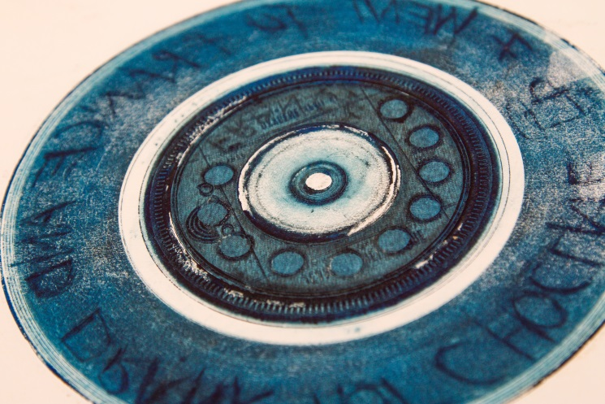

Key recommendations arising from this study are:

* Use this report as a tool to demonstrate the value of the Art-Ease Project and the KWHPC and for working with local commissioners and other funding bodies to identify possible sources of funding to secure ongoing delivery of the project.
* Explore opportunities for undertaking a whole system evaluation and SROI of the KWHPC to provide insight in to the ways in which it benefits the local community and promotes health and wellbeing in Knowle West and south Bristol.
* Identify ways for other local services, particularly the GP Practice and IAPT service, to appropriately refer clients to the Art-Ease Project, and to access other support services.
* Review data collection methods used by the Art-Ease Project in light of the outcomes captured by this SROI and identify ways to capture all relevant outcomes to project and future funders whilst ensuring that paperwork is minimised.

**Social Return on Investment – outcomes included and their values**

|  |  |  |  |
| --- | --- | --- | --- |
| **Outcome Indicator** | **Quantity** | **Financial Proxy** | **Value per participant** |
| Number of days Beneficiaries report creative fulfilment, pursuing art as a hobby at home. | 986 | Sense of self-worth and fulfilment equivalent to that of a part-time job (£6.31 an hour for 7.5 hours) | £47.33 |
| Number of Beneficiaries reporting new friendships, social relationships and a decrease in loneliness | 61 | Cost of attending a ten week -mixed media art group at the local community centre | £65.00 |
| Number of days Beneficiaries report feeling less down, improved concentration and more energy. | 986 | Cost of attending weekly stress counselling sessions | £42.00 |
| Number of occasions Beneficiaries report that art-group stops them being stuck at home and helps them to overcome mental barriers to leaving the house | 557 | Cost of a support work to collect Beneficiaries from house and take them out once a week | £21.69 |
| Number of occasions Beneficiaries report that they walk to the group and undertake additional exercise that they would not otherwise have undertaken as a result of coming to the group | 278 | Cost of a single gym activity (£4.50 per session) | £4.50 |
| Number of Beneficiaries reporting improved confidence, renewed sense of self and having the confidence to exhibit and present their art in public | 62 | Cost of 10 sessions with a life coach (£50 per session) | £500.00 |
| Number of Beneficiaries reflecting on the supportive, tolerant non-judgemental and accepting environment within the group. | 15 | Average cost of an online diversity training course | £30.00 |
| Number of Beneficiaries reporting that the support they receive through the art group and their fellow Beneficiaries means GP less attendance. | 30 | Average cost of a GP visit (£27.50 a visit) average reduction of 6 visits | £165.00 |
| Number of Beneficiaries claiming that without the support of the art group they would have had to re-engage with statutory mental health services | 6 | Cost of a two week stay in in inpatient mental health services (£445 a day) | £6,230.00 |
| Number of Beneficiaries citing improved family/household relationships | 30 | Cost of 5 sessions of family therapy (£40 a session) | £200.00 |
| Number of volunteers reporting acquisition of personal development / career skills and opportunities | 4 | Cost of attending an art in mental health foundation training course with volunteer support | £860.48 |

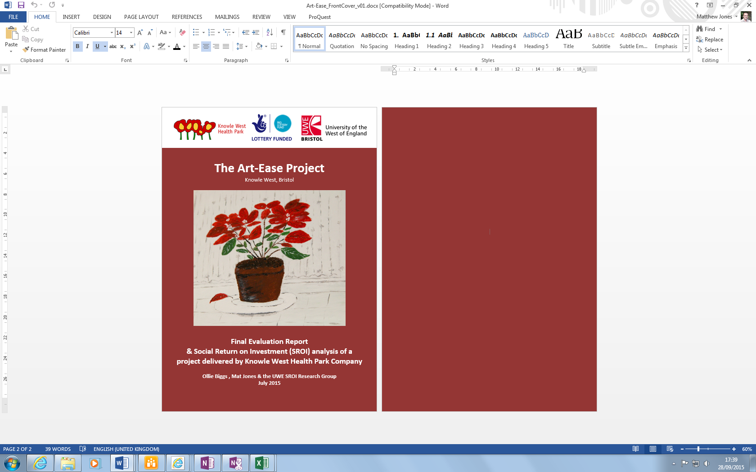

This study was led by Olly Biggs (UWE), Mat Jones (UWE) with support from Sarah Weld (Specialty Public Health Registrar), Richard Kimberlee (UWE) and Phil Aubrey (Well UK).

We would like to acknowledge and thank all the KWHPC staff, participants and partner agency staff for their support and assistance in undertaking this research.

Photographs in this report show work produced by participants in the Art-Ease Project.

For full **Evaluation & SROI Report** and details of the wider evaluation of the South West Wellbeing programme see: <http://westbank.org.uk/>

Or contact Mat Jones [matthew.jones@uwe.ac.uk](mailto:matthew.jones@uwe.ac.uk)

For details on the Knowle West Health Park Company contact Sue Cooke [scooke@knowlewesthealthpark.co.uk](mailto:scooke@knowlewesthealthpark.co.uk)

**JULY 2015**

1. Jones, M., Kimberlee, R. *et al.* (2013) [The Role of Community Centre-based Arts, Leisure and Social Activities in Promoting Adult Well-being and Healthy Lifestyles](http://eprints.uwe.ac.uk/18155/). *Int. J. Environmental Research & Public Health,* 10 (5). 1948-1962. [doi.org/10.3390/ijerph10051948](http://dx.doi.org/10.3390/ijerph10051948)
2. Faculty of Public Health. Better Mental Health for All. <http://www.fph.org.uk/better_mental_health_for_all>
3. Centre for Mental Health. The economic and social costs of mental health problems in 2009/10. <http://www.centreformentalhealth.org.uk/pdfs/economic_and_social_costs_2010.pdf>
4. Glasgow R et al (1999) Evaluating the public health impact of health promotion interventions: the RE-AIM framework. *Am J Public Health* 89:1322-1327.